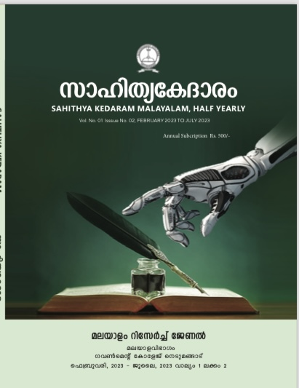
EDITORIAL BOARD
Editor:
Dr. Alex L
Professor & Head
Post Graduate Department of Malayalam
Government College Nedumangad
Email: alexl@gcn.ac.in

Editorial Board:
Dr. Dharmarajan S S
Associate Professor
PG & Research Department of Malayalam
Government College Nedumangad
Email: dharmarajanss@gcn.ac.in

Dr. Pramod Kumar D N
Associate Professor
PG & Research Department of Malayalam
Government College Nedumangad
Email: pramodkumardn@gcn.ac.in

Dr. Rajesh Kumar P S
Associate Professor
PG & Research Department of Malayalam
Government College Nedumangad
Email: rajeshkumarps@gcn.ac.in

Dr. Deepa S S
Assistant Professor
PG & Research Department of Malayalam
Government College Nedumangad
Email: deepass@gcn.ac.in

Sri. Sreeraj C L
Assistant Professor
PG & Research Department of Malayalam
Government College Nedumangad
Email: sreerajcl@gcn.ac.in

Dr. Susanna P Das
Assistant Professor
PG & Research Department of Malayalam
Government College Nedumangad
Email: susannapdas@gcn.ac.in

Dr. Lekshmi S
Assistant Professor
PG & Research Department of Malayalam
Government College Nedumangad
Email: lekshmis@gcn.ac.in

