GOVERNMENT COLLEGE, NEDUMANGAD
HISTORY CLUB ACTIVITIES REPORT 2022-23

The purpose of club activities in colleges is to cultivate a sense of unity among students and working with others in reaching the same goals. These extension activities develop social skills and facilitate students to meet, mix, and work together with other students from different backgrounds in a diverse environment. History club is such a platform to learn and discuss historical events, conduct activities related to current historical events and to visit historical sites. It also helps to understand the activities of people and societies in the past as well as in the present day through historical studies. ·

HERITAGE WALK 2022
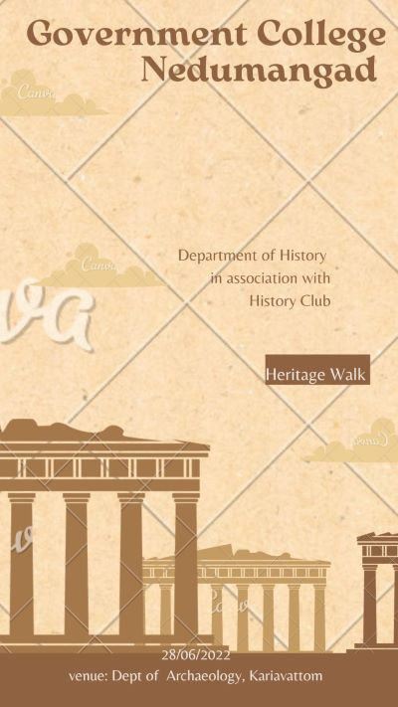
Department of History in association with History Club visited an exhibition organised by Department of Archaeology , Kariavattom on 28 June 2022. The exhibition displayed various antique treasuries like, coins, Cadjan records, other ancient artefacts, human remains etc. The students were very excited to see an incredible display of 5000 years old human skeleton in this exhibition. Dr Bijikumary and Thushad T, Faculty members of History accompanied PG students to the exhibition.
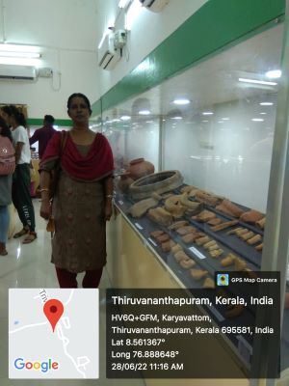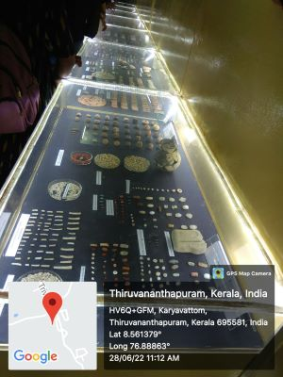
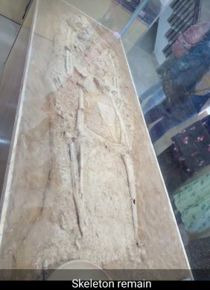
AZADI KA AMRIT MAHOTSAV

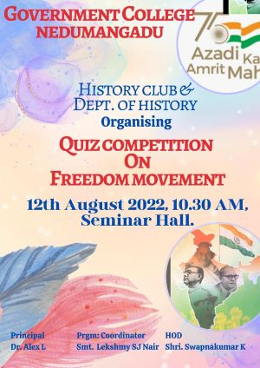

Department of History in association with History Club conducted a Quiz Competition on Freedom Movement on 12 August 2022 as part of Azadi ka Amrit Mahotsav. On this 15 August 2022 marks the completion of 75 years of Independence and to commemorate and celebrate 75 glorious years of progressive India and its rich history, diverse population, magnificent culture and great achievements.A documentary on' Fressdom Fighters was also broadcast at the event. The Principal distributed the prizes to the winners of the quiz competition.

