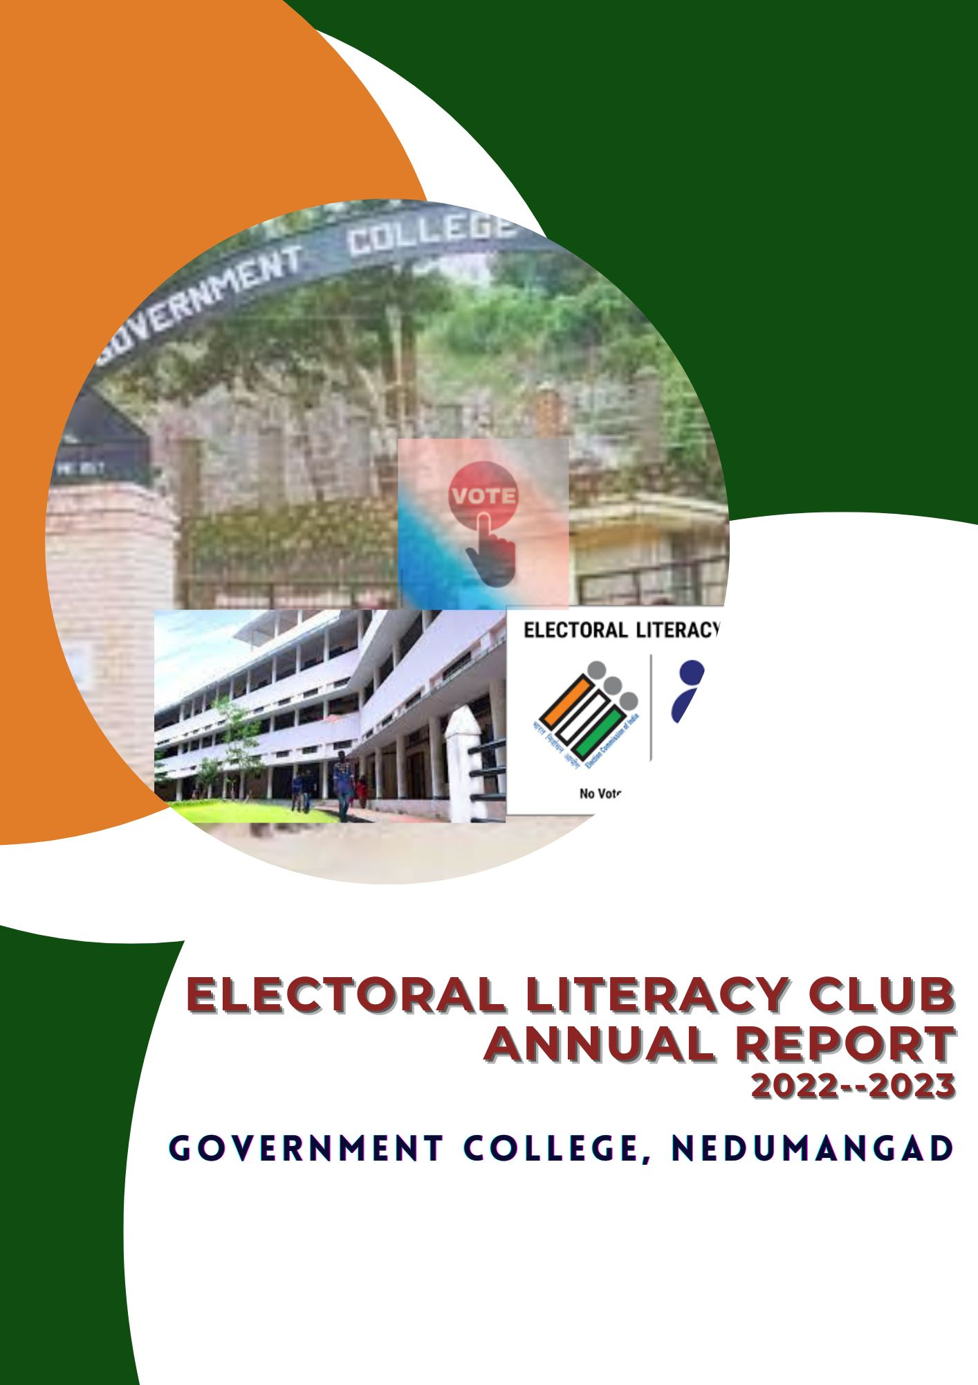
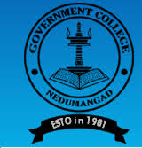

GOVERNMENT COLLEGE, NEDUMANGAD
THIRUVANANTHAPURAM
REACCREDITED BY NAAC WITH A GRADE (CGPA 3.07)

ELECTORAL LITERACY CLUB

ANNUAL REPORT
2022-2023

Electoral Literacy Club
ELC Co-ordinator : Smt. Jisha Abraham(Department of Political Science)
Campus Ambassodors: Mr. Amrith Surendren(II BA History)
: Ms. Arya V.S. (II B A Economics)
ELECTORAL LITERACY CLUB (ELC)
ELC stands for Electoral Literacy Club. The primary objective of the club is to sensitize the student community about democratic rights which includes casting votes in elections. We conductedAwareness class, debates, Quiz, Flash Mob and other programmes to create an awareness regarding the electoral procedures and to give the experience based learning of the democratic setup.
Vision
Originating in integrated civic and voter education and electoral participation right to make its utmost contribution to have an active democratic citizenry from a young age.
Mission
- To educate the targeted populations about voter registration, electoral process and related matters through hands on experience.
- To familiarize the targeted populations with EVM and VVPAT and to educate them about robustness of EVM and integrity of the electoral process using EVMs.
- To help the target audience understand the value of their vote to ensure that they exercise their suffrage right in a confident, comfortable and ethical manner.
- To harness the potential of ELC members for carrying the electoral literacy in communities.
- To facilitate voter registration for its eligible members who are not yet registered.
- To develop a culture of electoral participation and maximize the informed and ethical voting and follow the principle ‘Every vote counts’ and ‘No Voter to be Left Behind’.

Report of Electoral Literacy Club 2022-2023
Inauguration of Electoral Literacy Club
The inauguration of Electoral Literacy Club was held on August 29, 2022. The programme wasinaugurated byDr. Alex L, Principal, Government College, Nedumangad. He reminded thestudents about the importance of deciding and casting a vote during the elections and also madethem aware about the possibilities. In par with the inauguration, an Awareness Class was also arranged for enabling thestudent community to be dutiful in directing their individual vote to the whole of concept ofnation building. The class was handled byShri.Suresh Kumar P.S, Deputy Election Tahsildar, Nedumangad&Shri.M.R Binu, Senior Clerk of Taluk Office . Thesession was interactive and they familiarized the students the concept of voting and votingprocedures.

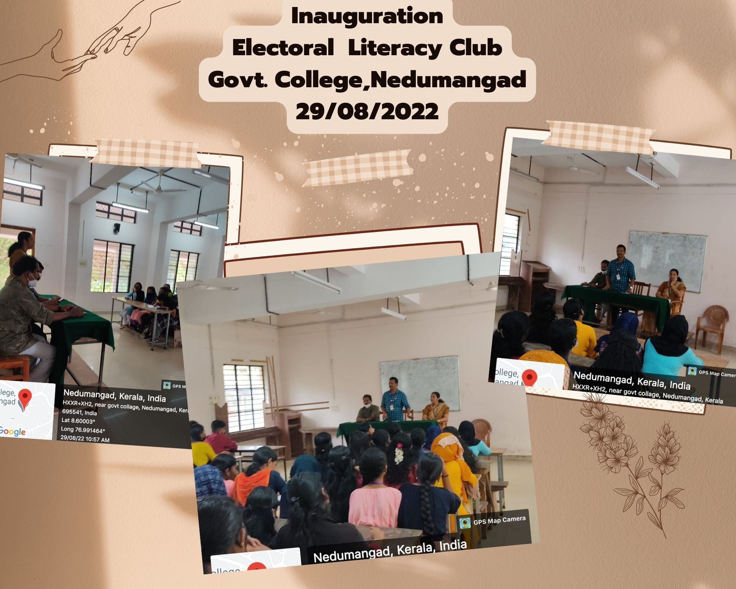

Linking Voter ID With Aadhar
Linking Aadhaar with voters' identity cards is a major step towards voting, an initiative launched by the Election Commission of India (ECI). The electoral literacy club of the college in association with Taluk Office,Nedumangad, Thiruvantahapuram District organized an awareness campaign to enroll the new electors through a mobile app. The class was handled by Suresh Kumar P.S, Deputy Election Thahsildar, Nedumangad & M.R Binu ,Senior Clerk of Taluk Office .They also introduced the new mobile– (Voters Helpline App) application for acquiring new voter ID card. The club members were organized an awareness campaign of the new mobile app to the students.The club organized an awareness campaign on 22nd September 2022 in collaboration with the Taluk Office,Nedumangad. All the club members participated the programme and theShri.Ajeesh Kumar,Clerk of Taluk Officetrained the students toregister the voters ID with Aadhar through online.
Camp I
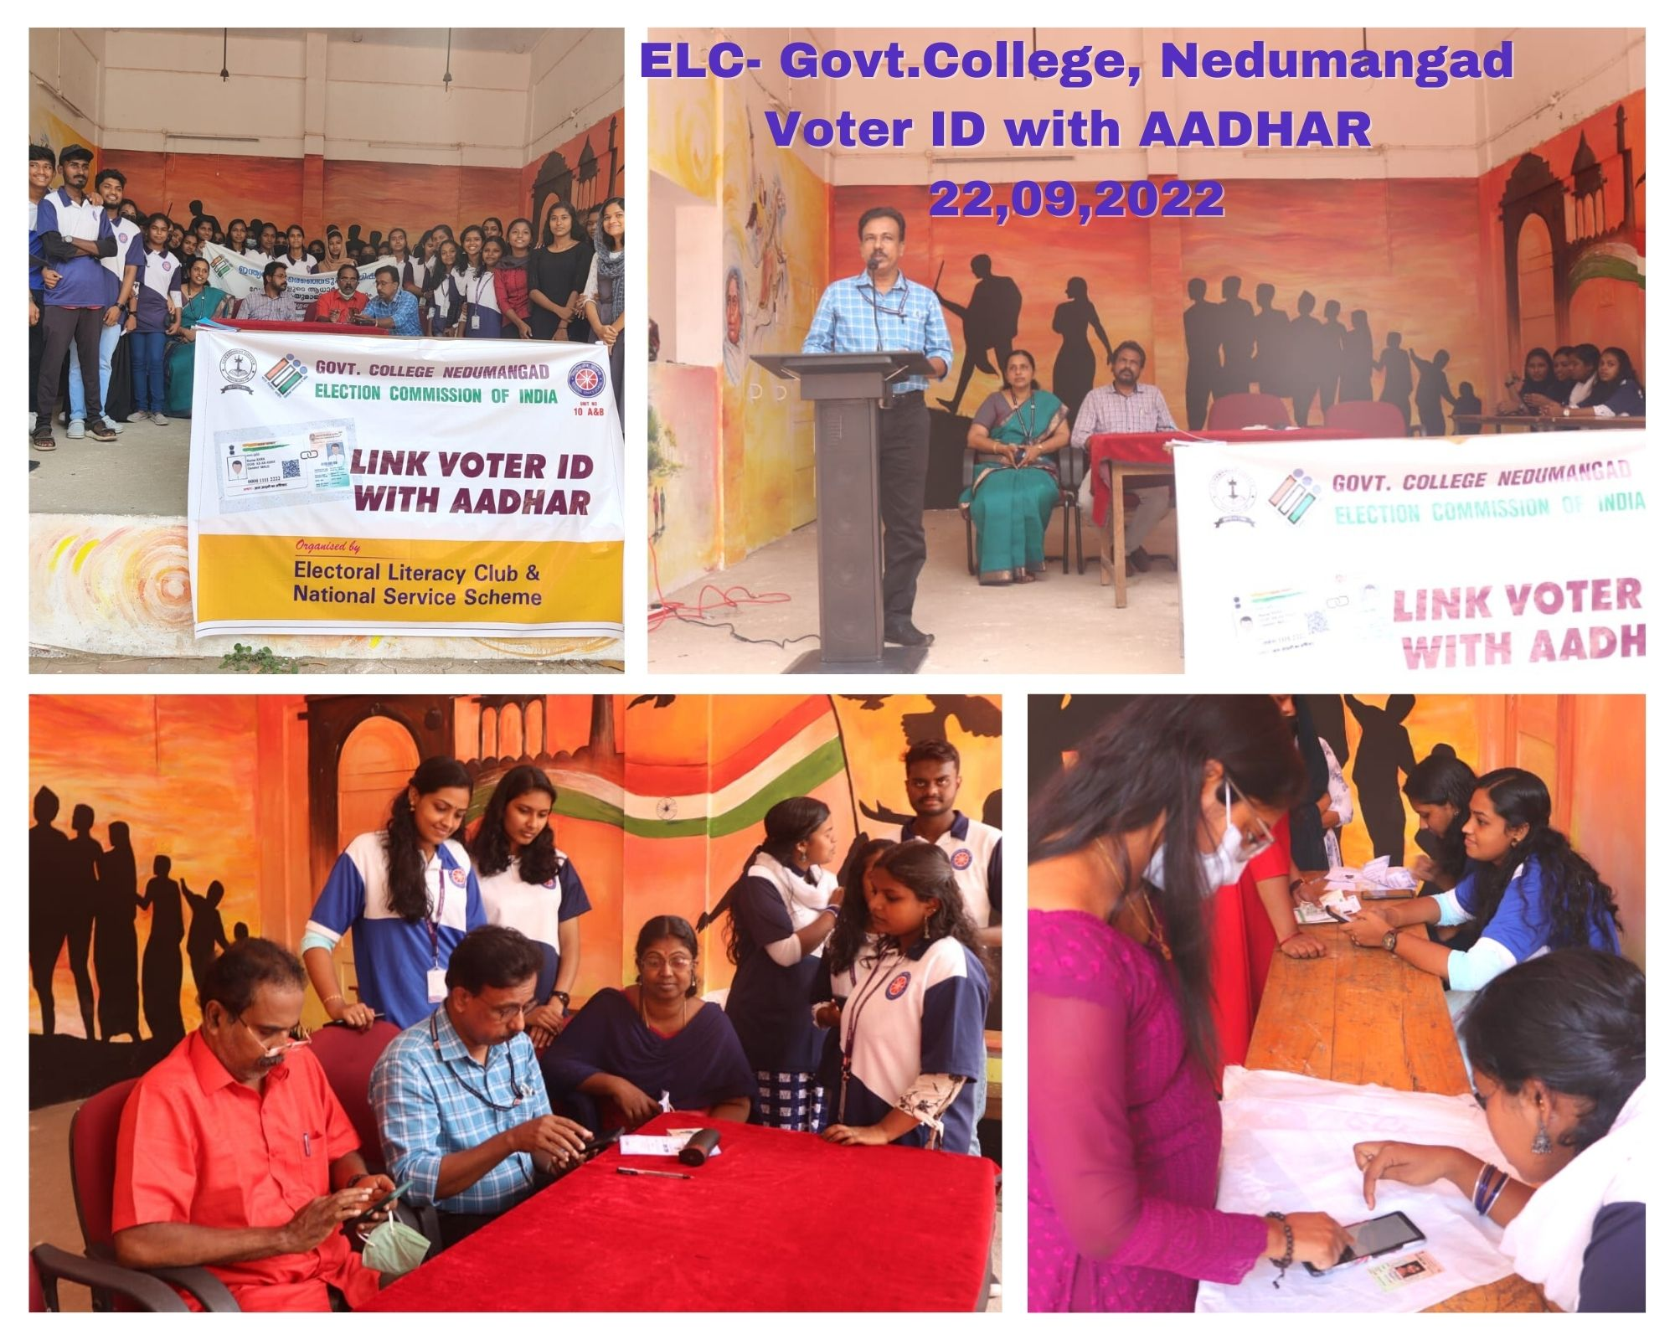
Camp II
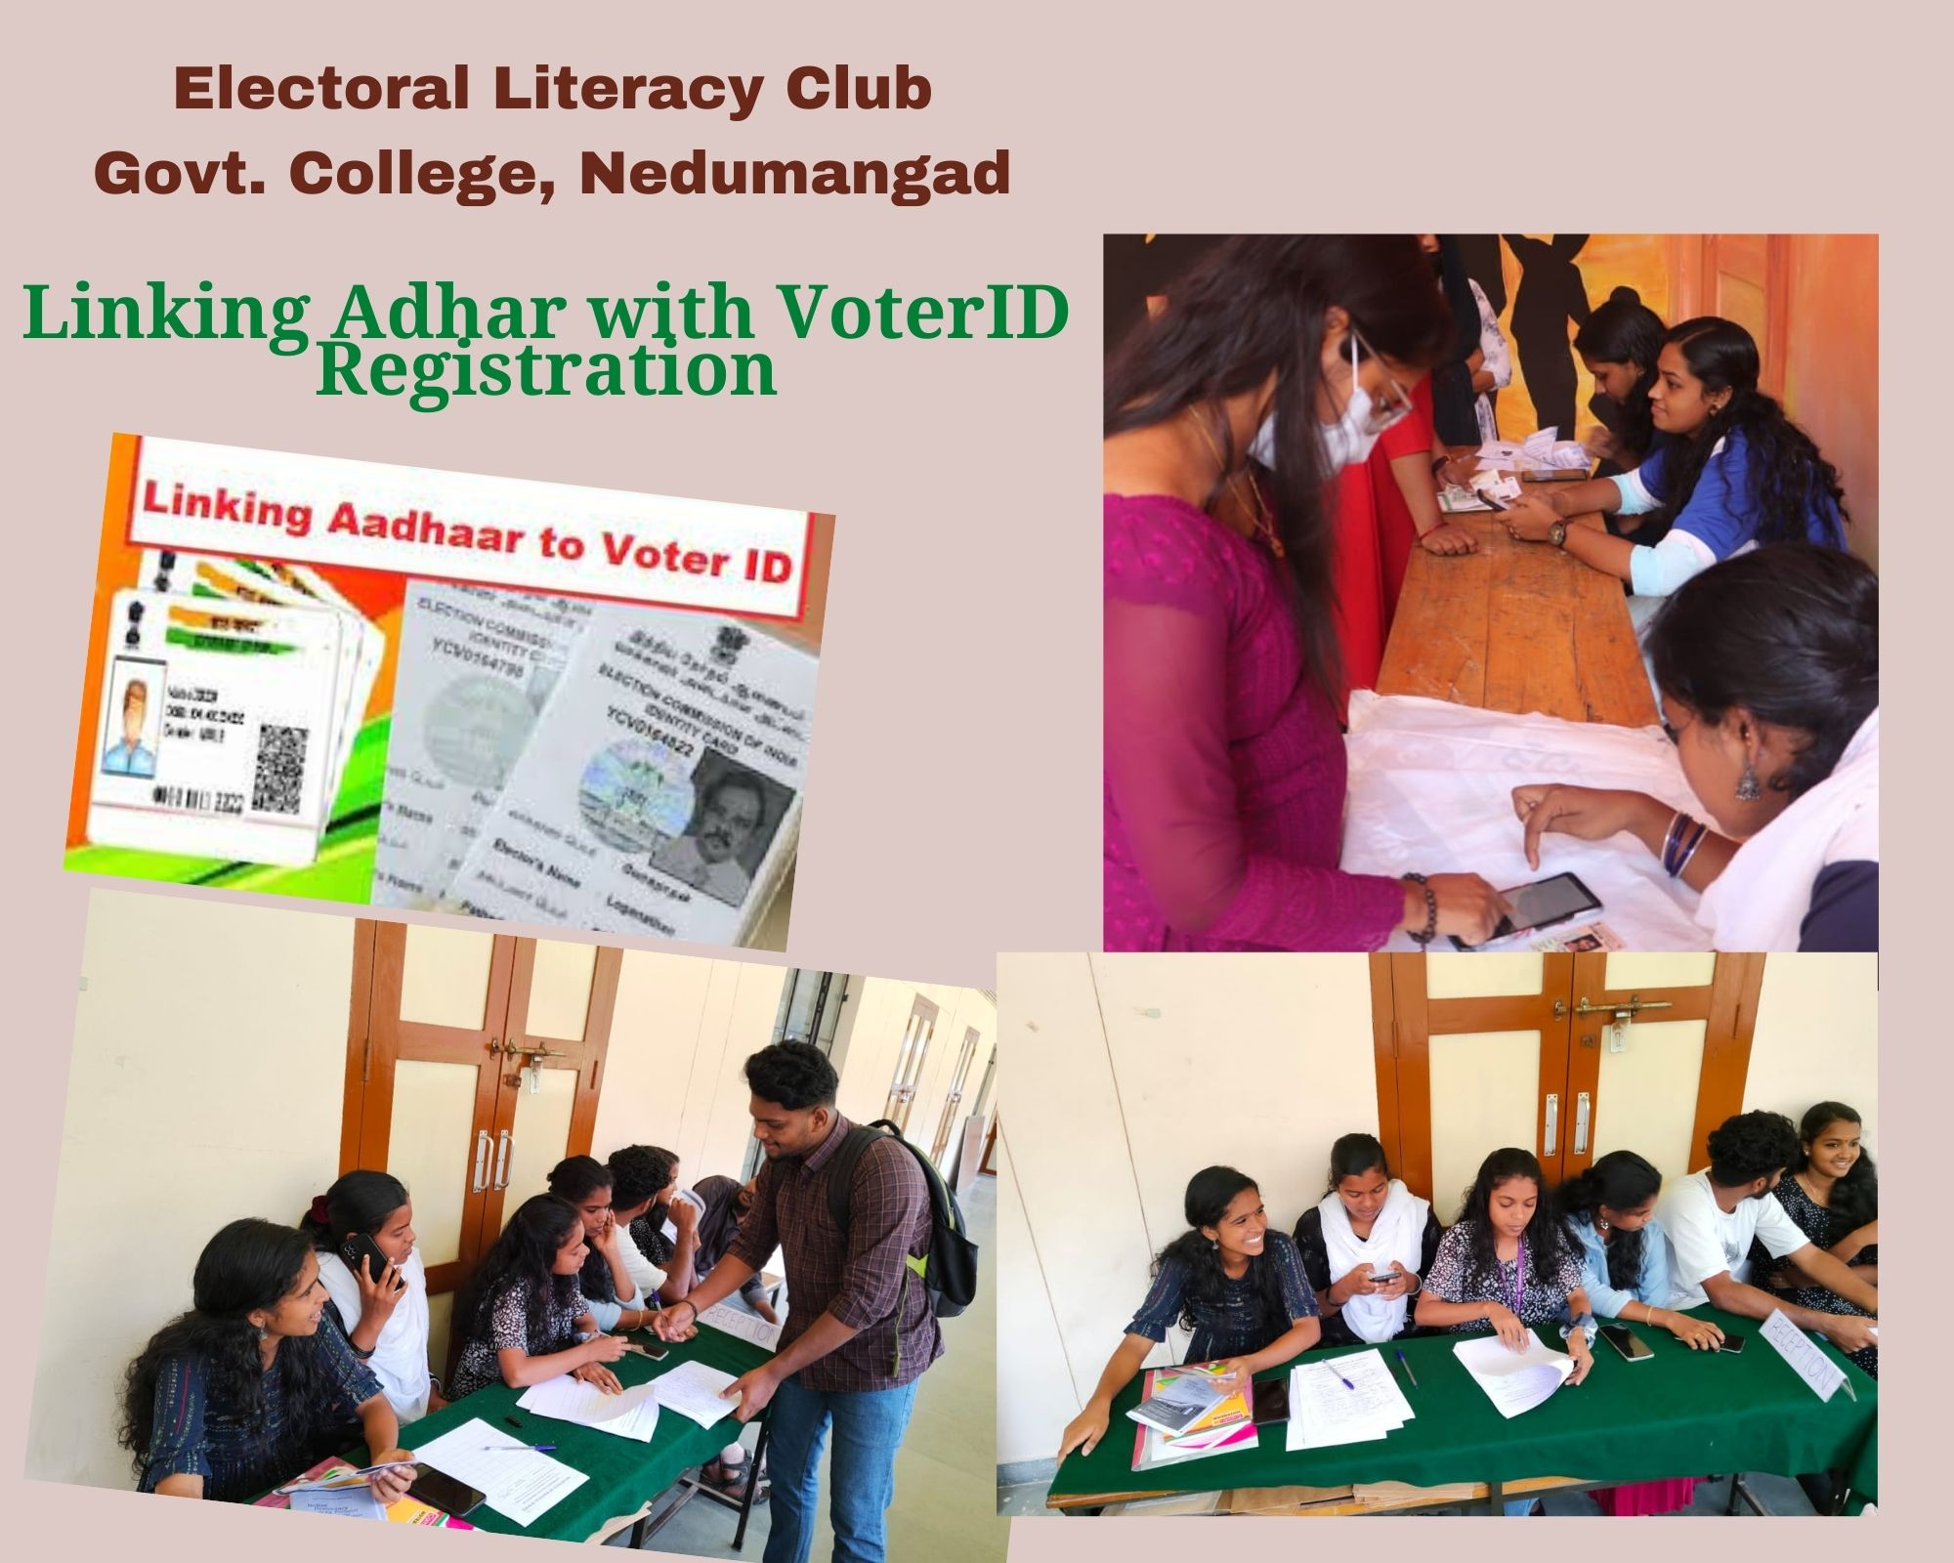

Flash Mob
The flash mobs have been organized as part of the Systematic Voters’ Education and Electoral Participation (SVEEP) programme on 09/11/2022 at Tribal Settlement ,Kottoor. This was a new experience to the students and it could help a lot in spreading the importance of exercising the franchise among the common people, especially the youth.
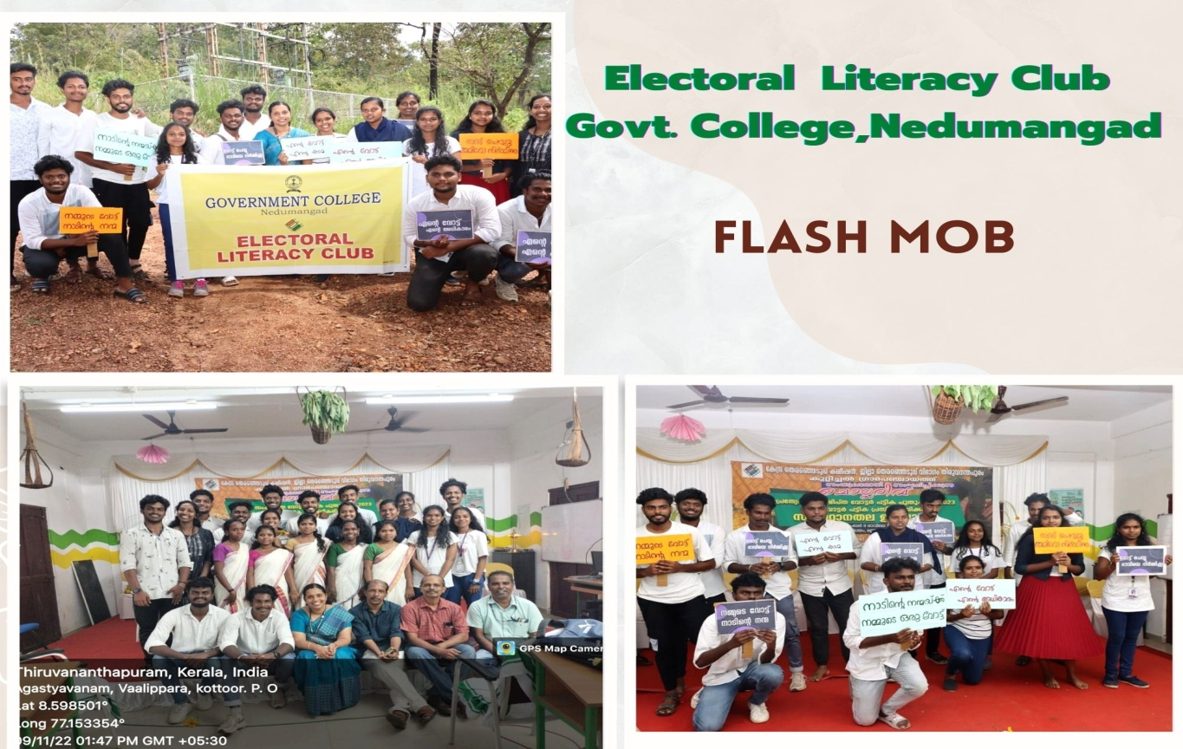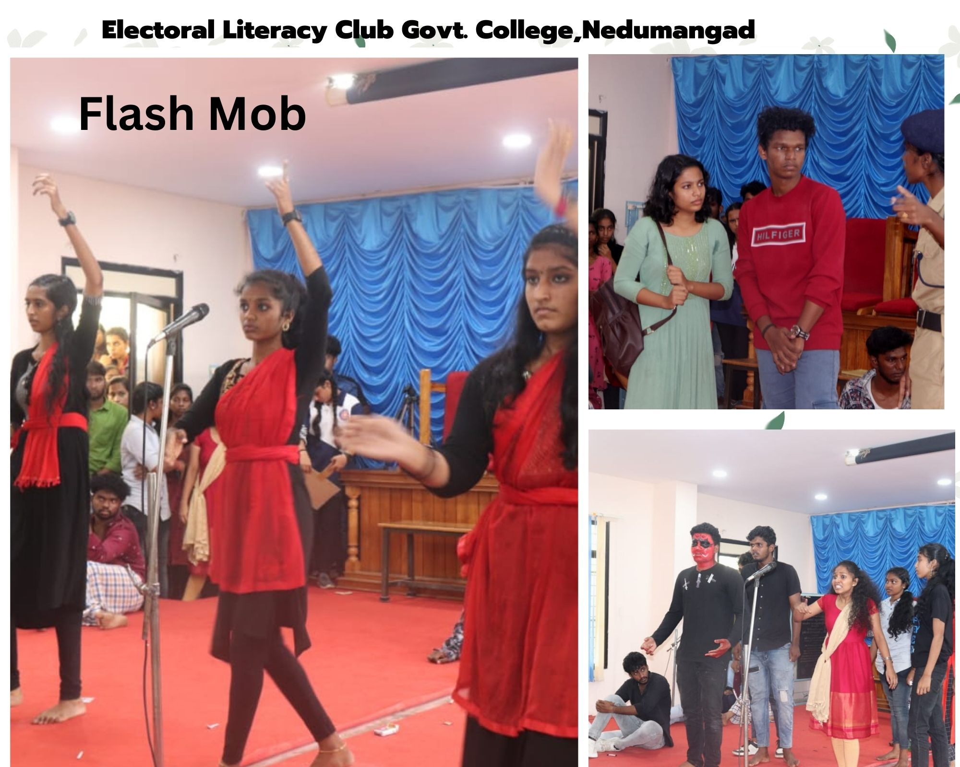
Special Summary Revision (SSR) Camp
Special Summary Revision(SSR) for creating awareness amongst general public about important information relating to Special Summary Revision such as commencement of SSR, publication of draft roll, special campaign dates, publication of final publication roll etc. The ELC students participated in the Marathon at Tribal Settlement on 09/11/2022.

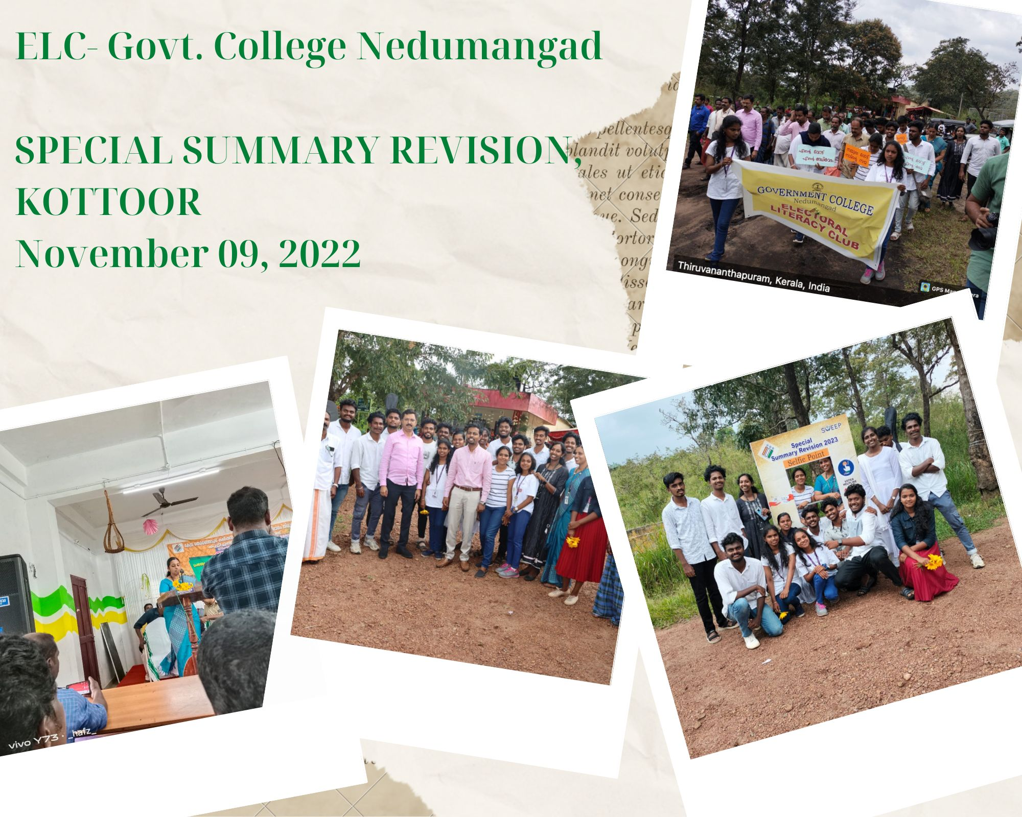

Quiz Competition
The Competition aims to educate the students about their fundamental rights so as to develop the human personality and strengthen respect for human rights and fundamental freedoms. For empowering the students and preventing violation of human rights and make them to be a civic citizens, by giving awareness on the basic concepts of our constitution. The College observed the constitutional day on 26th November 2022. They took pledge and participated the quiz competition conducted by the ELC of the college on 24/11/2022.

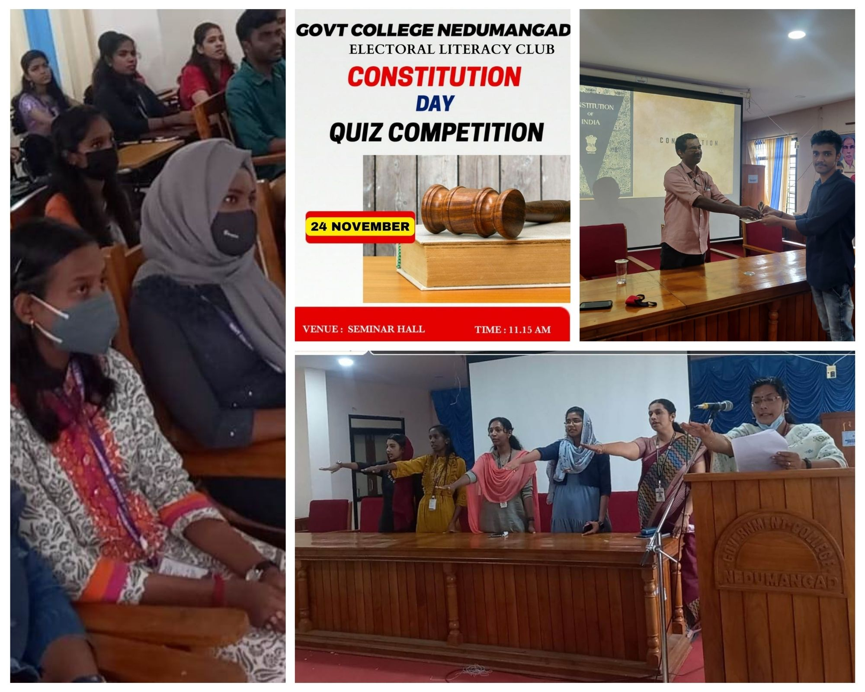

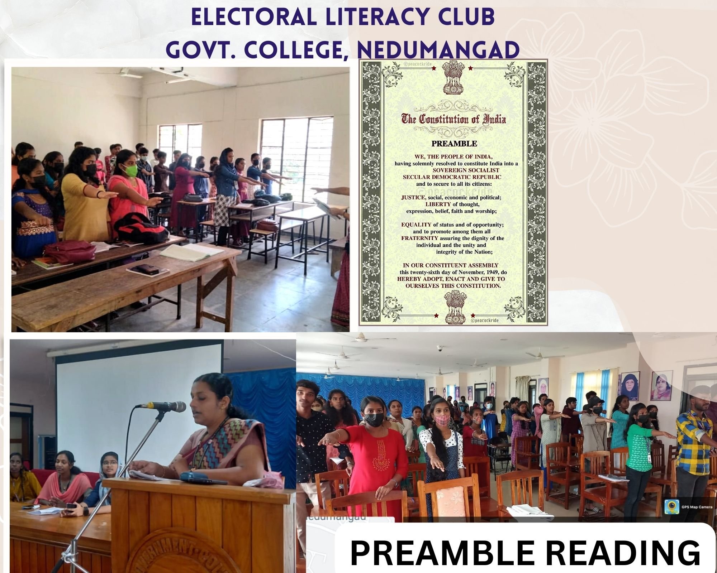

Discussion on Indian Constitution and Electoral Politics
A class was arranged for the members of the club in order to make the students acquaint with the structure– Indian Constitution and Electoral System on November 25, 2022. Students were asked to speakfor five minutes on the topic. The discourse of realization of the idea of Indian Constitution of India and the issues of bridging the elite and grassroots democracy, strengthening people’s participation and making politics work for development. It will also focus on the democratic ideals of India, which constructed its identity and influence across the world as a responsible and peaceful power. There after an open forum for discussing the same was arrangedwhere all the students engaged in a creative give and take of the topic. Dr.Anas.S, Asst.Prof, Dept of Political Science, Iqbal College, chaired the session and Ananda Jyothi, Asst.Prof of Economics,Govt.College, Nedumangad bid thanks to all the participants’ for their activeparticipation.

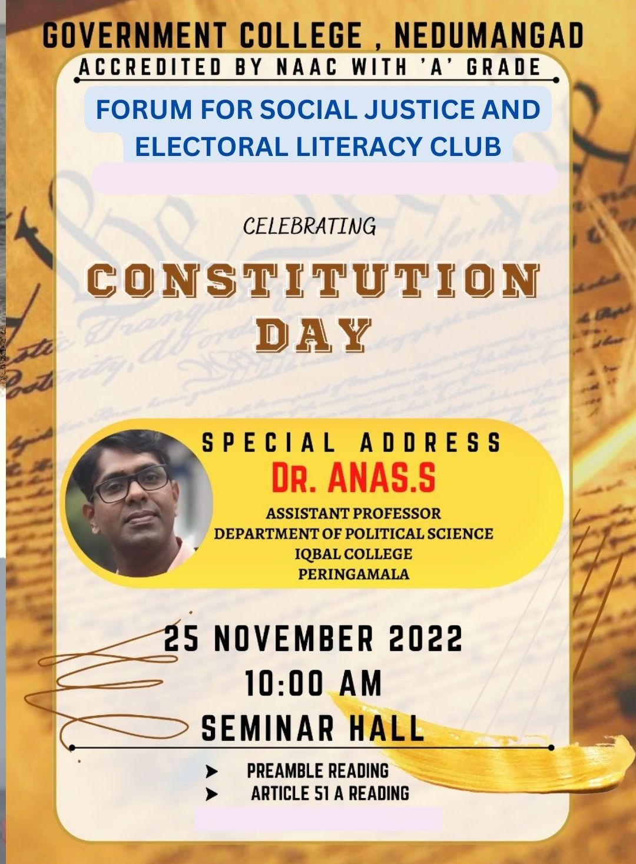
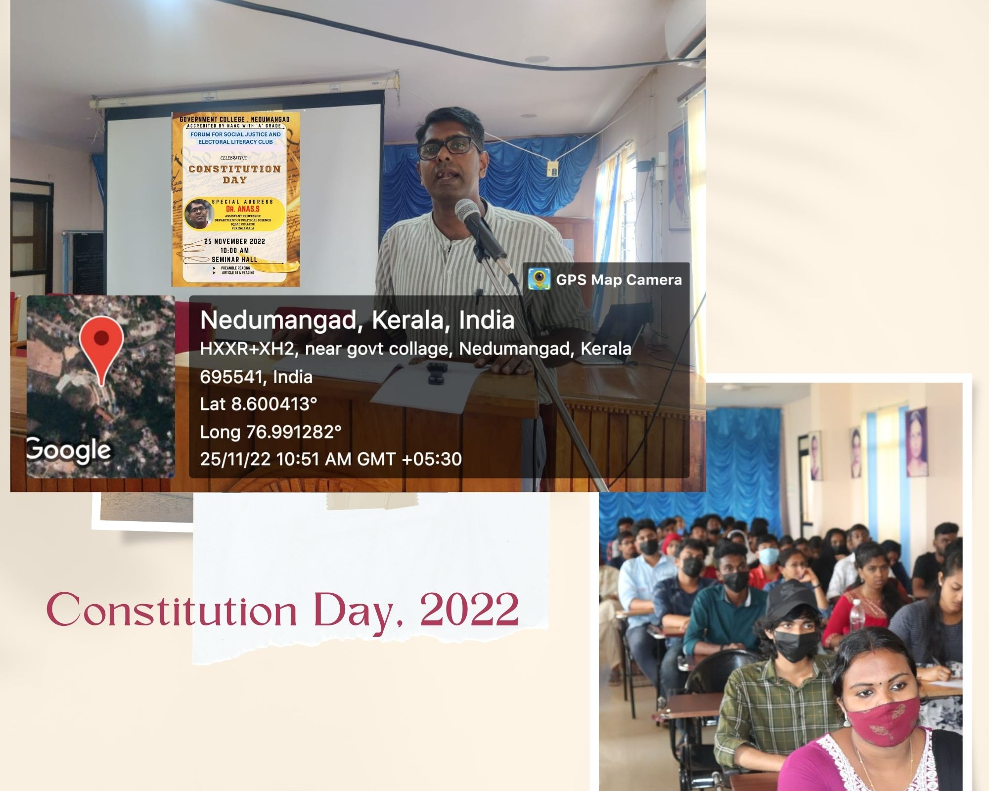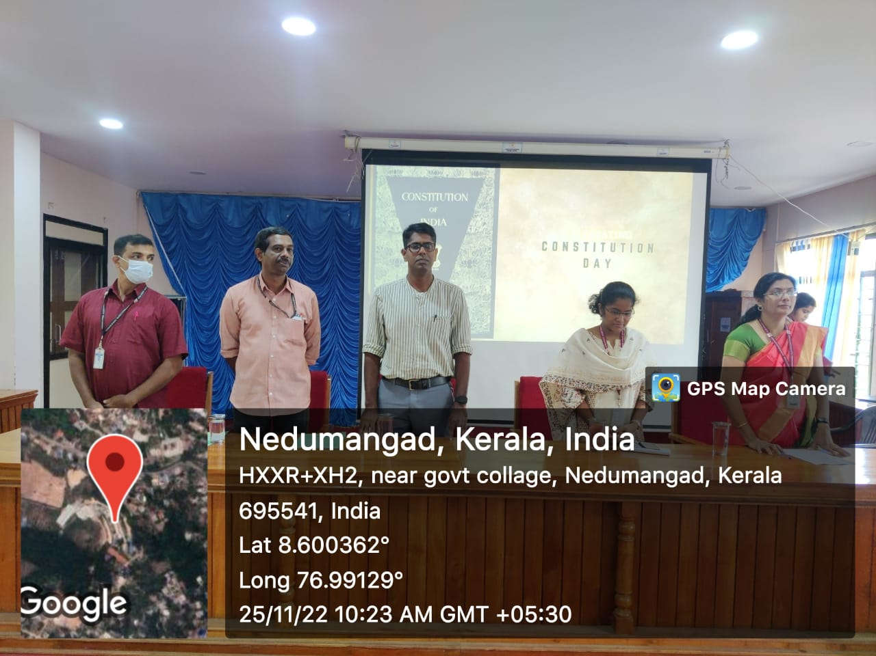

Election Awareness Class
An election awareness class was arranged for the members of the club in order to make the students acquaint with the electoral system on December 9, 2022. The class was handled by Shri. Chandran Komath, Asst.Prof.,Department of Political Science, Government College, Nattakam, Kottayam.The session was productive as it gives the students aninsight into the structure of Indian electoral system and to identify the pillars of our constitution is connected with its greatness and to realize the need of protecting and preserving parliamentary democracy. Ithelped thestudents from different discipline to understand the need to know and participate country’s changingpolitical scenario and to realize the need of protecting and preserving parliamentarydemocracy.

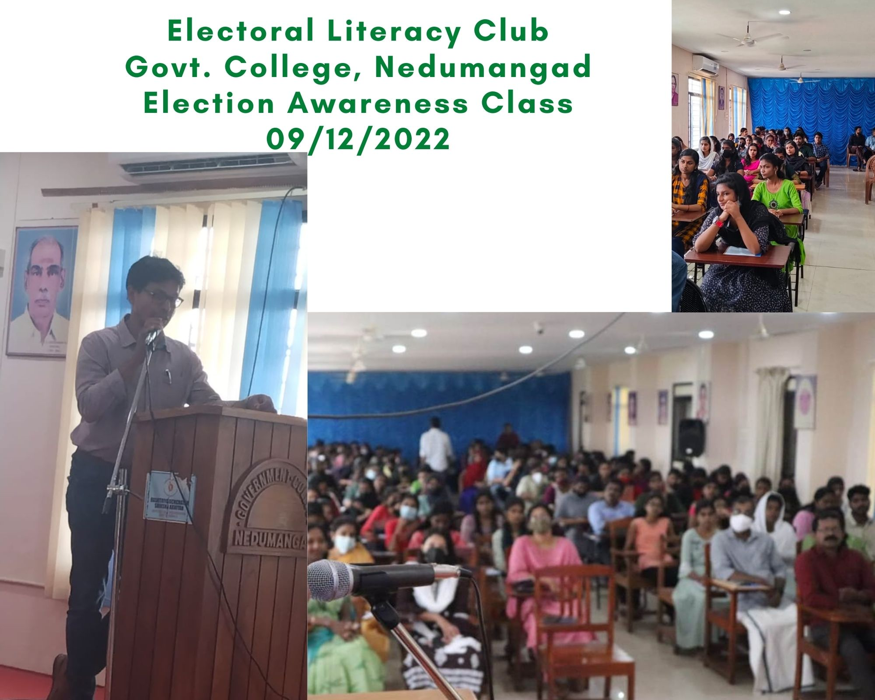

Voter Enrolment Camp- Form 6
Voter Card enrolment helpdesk was put up and Form 6 bourchures were distributed to the newly eligible voters. Students and staff members took an oath to uphold their faith in democracy and vote fearlessly in every election. Principal of the College, Dr.Alex .L graced the event and addressed the young voters. He advised the students to use the hard earned right to vote sagaciously.

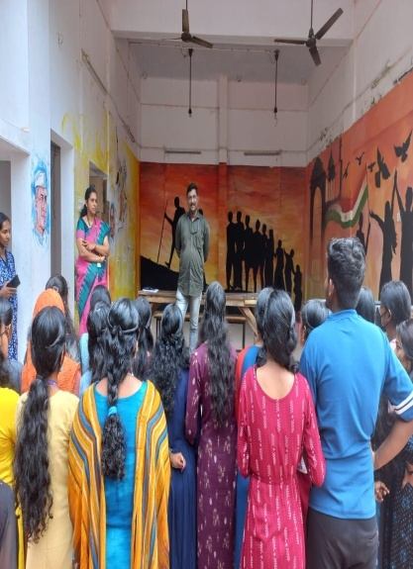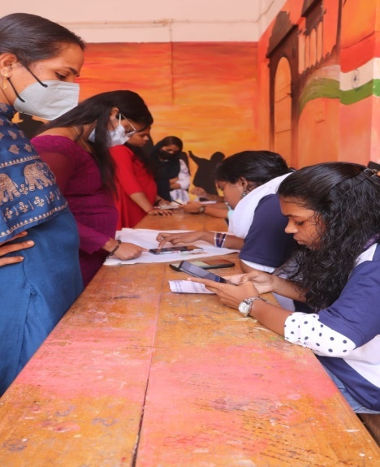
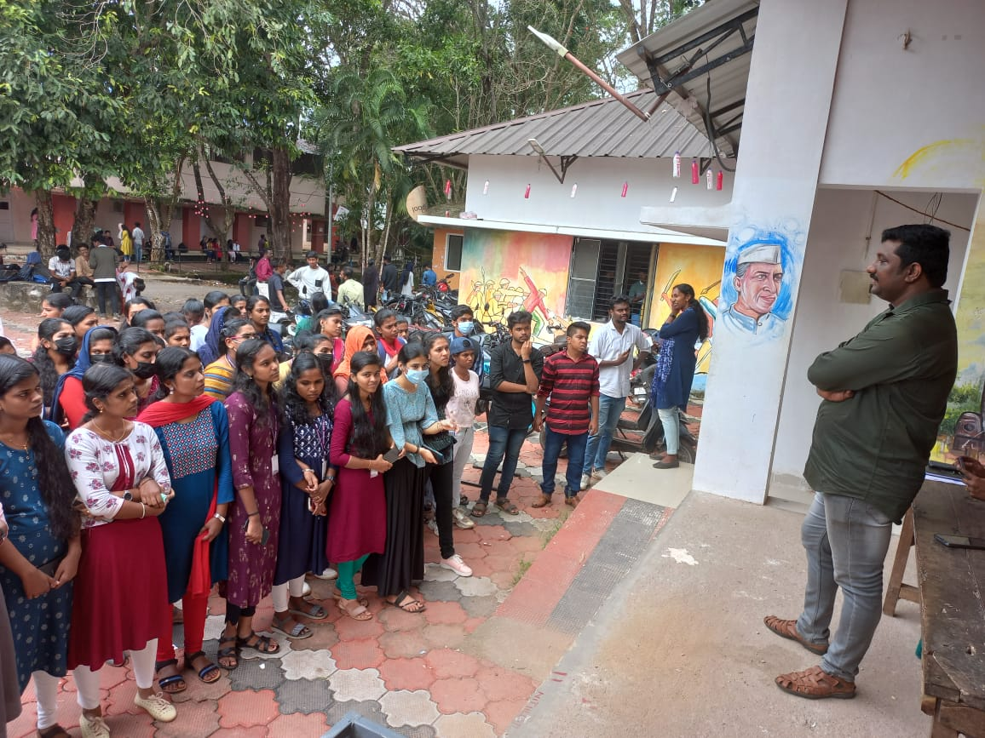

Campaign in NSS Camp
An awareness session for the students for creating to enrol the names of voters list in the seven day residential camp for NSS volunteers held at Higher Secondary School, Poovathoor,Nedumangad on 29/12/2022 at 10.00 am. The class was handled by Shri.Suresh Kumar P.S, Deputy Election Tahsildar, Nedumangad & Shri.M.R Binu, Senior Clerk of Taluk Office . The session was interactive and they familiarized the students the concept of voting and voting procedures.

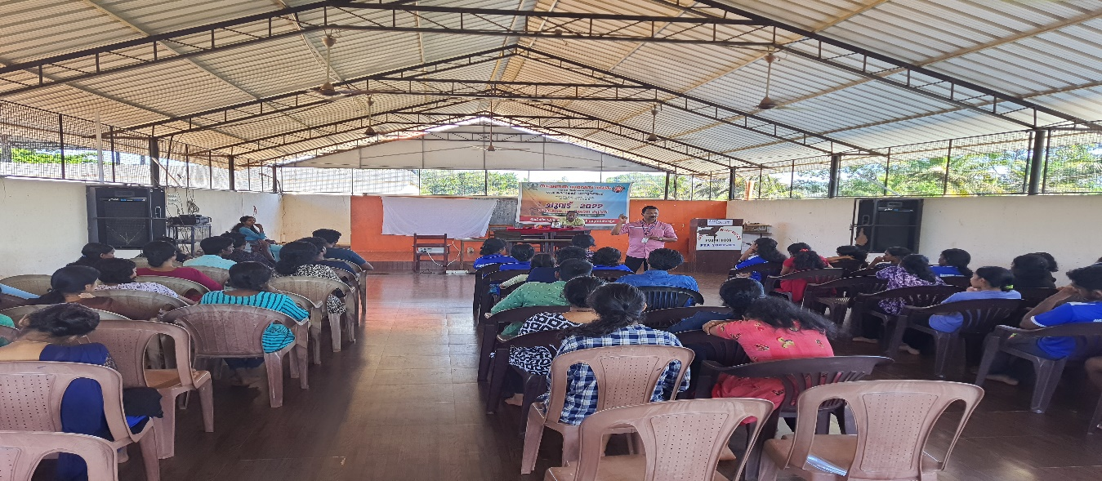

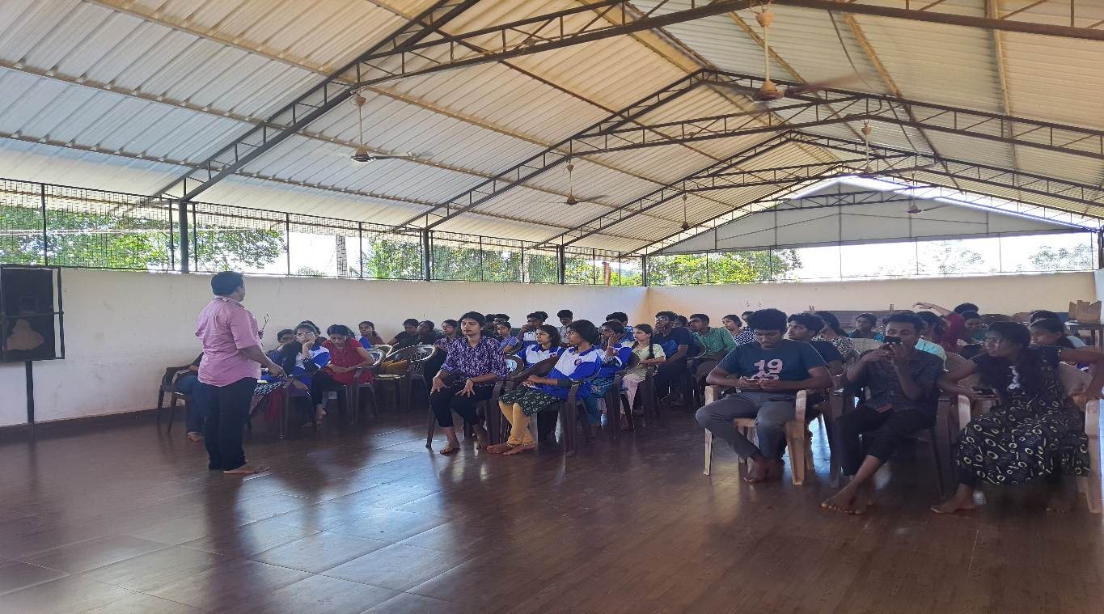
Inter Collegiate Quiz Competition
Our college 20 students participated in an Inter-college Quiz Competition held at Collectorate Office,Thiruvananthapuram on the theme ‘Electoral Literacy’ on 5th January 2023.
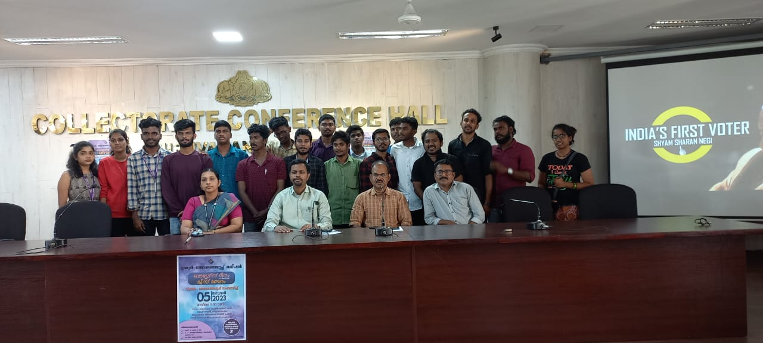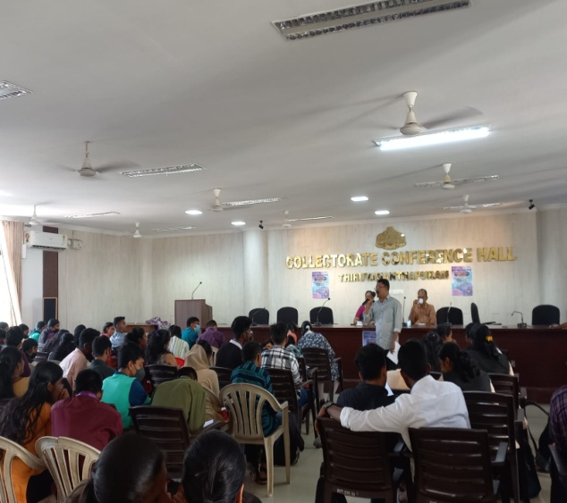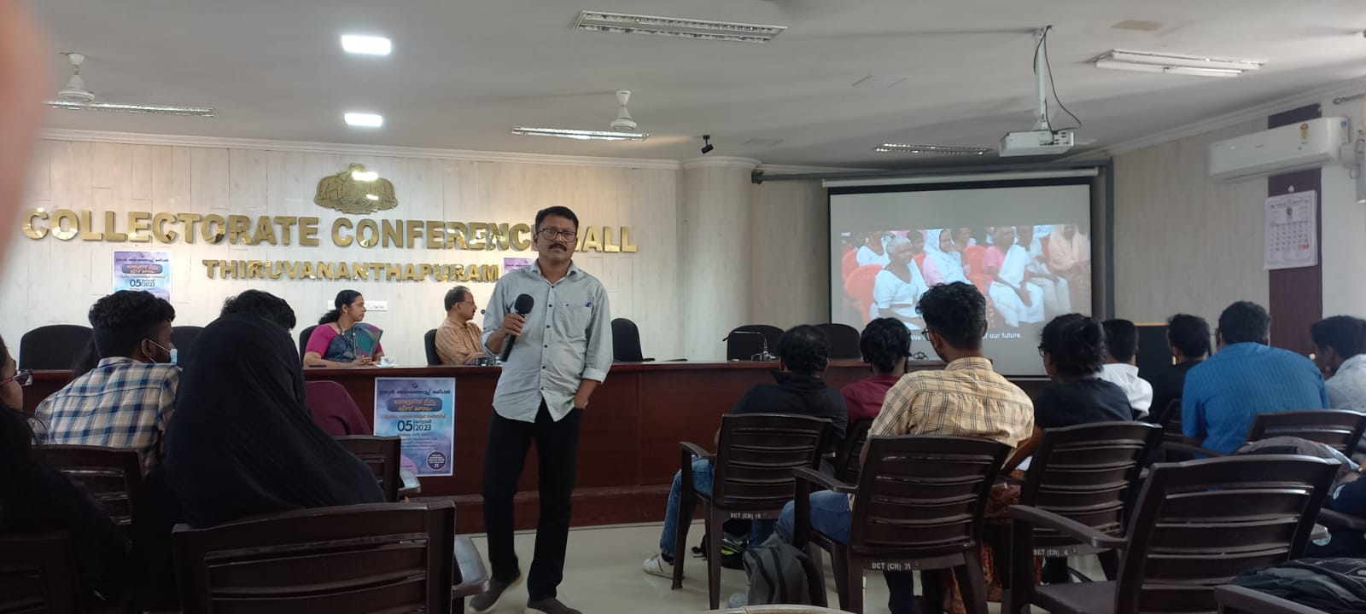

Award
The Electoral Literacy Club of Government College, Nedumangad has been selected as the Best Electoral Literacy Club in Thiruvananthapuram District in connection with the National Voters Day ,2023.
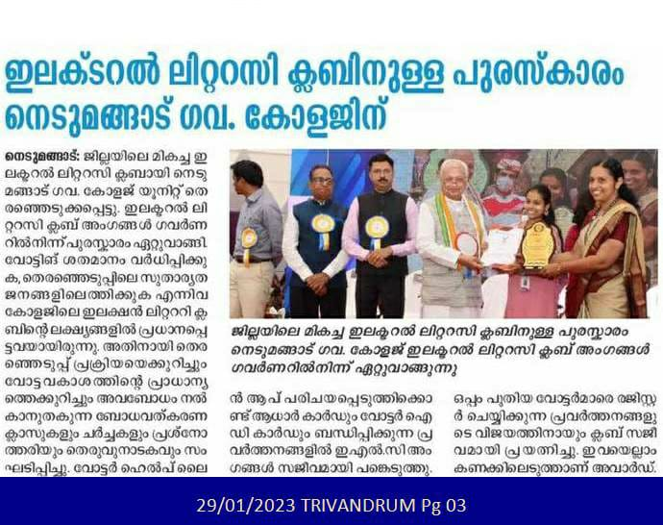
SL.NO | PROGRAMMES | UDERTAKEN
1 | No.of activities undertaken by the ELC during SSR  Such as New Voter Registration Desk(Form 6B & Form 6) | 6 Camp
2 | No. of New Voters | Above 120  (approx)
3 | Social Awareness Activities Under taken for PwD,TribalAreas,etc | Tribal Settlement ,Kottoor on 9/11/2022.ELC members gave special attention to these category and they actively involved in social awareness programmes.
4 | ELC members | 113 ELC Students
5 | No. of group activities done y the students | 13 Activities

Smt. Jisha Abraham Dr. Alex L.
Coordinator Principal
Electoral Literacy Club Govt. College, Nedumangad
Govt. College, Nedumangad

GOVERNMENT COLLEGE, NEDUMANGAD
LIST OF ELECTORAL LITERACY CLUB MEMBERS 2022-2023
Sl No | CLASS | NAME OF THE STUDENTS | REMARKS
1 | III SEM ECONOMICS | ANAND M.M
2 | III SEM ECONOMICS | ANUSREE A S
3 | III SEM ECONOMICS | ARSHA K S
4 | III SEM ECONOMICS | FATHIMA. S
5 | III SEM ECONOMICS | LEKSHMI. D
6 | III SEM ECONOMICS | MERLIN S
7 | III SEM ECONOMICS | SHIFANA S
8 | III SEM ECONOMICS | SURALEKSHMI R.S.
9 | III SEM ECONOMICS | ABHAY . S . L
10 | III SEM ECONOMICS | ABHIJITH J.
11 | III SEM ECONOMICS | ABHIRAMY A
12 | III SEM ECONOMICS | AMAL A
13 | III SEM ECONOMICS | AMAL S
14 | III SEM ECONOMICS | AMALDEV J
15 | III SEM ECONOMICS | ANCY S
16 | III SEM ECONOMICS | ANEESHA J A
17 | III SEM ECONOMICS | ANUBHAMA M.S.
18 | III SEM ECONOMICS | APARNA BABU
19 | III SEM ECONOMICS | ARATHY. L
20 | III SEM ECONOMICS | ARCHA A.
21 | III SEM ECONOMICS | ARYA B.M
22 | III SEM ECONOMICS | ARYA MURALI
23 | III SEM ECONOMICS | ARYA V.S. | CAMPUS AMBASSODOR
24 | III SEM ECONOMICS | ASHFAK MOHAMMED . N.S
25 | III SEM ECONOMICS | ATHIRA A
26 | III SEM ECONOMICS | ATHIRA K B
27 | III SEM ECONOMICS | ATHIRA S.S.
28 | III SEM ECONOMICS | ATHIRA V S
29 | III SEM ECONOMICS | EEVA M. E.
30 | III SEM ECONOMICS | GOPIKA J
31 | III SEM ECONOMICS | JIMSHA P V
32 | III SEM ECONOMICS | KAVYA RAJENDRAN
33 | III SEM ECONOMICS | KRISHNA KRIPA S A
34 | III SEM ECONOMICS | KRISHNADEV R.
35 | III SEM ECONOMICS | LEKSHMI. A.R
36 | III SEM ECONOMICS | MALAVIKA S KUMAR
37 | III SEM ECONOMICS | MANNYA M S
38 | III SEM ECONOMICS | NANDANA R
39 | III SEM ECONOMICS | NANDANA. S
41 | III SEM ECONOMICS | RESHMA A G
42 | III SEM ECONOMICS | RUFANA.N
43 | III SEM ECONOMICS | SHYAM CHANDRAN C
44 | III SEM ECONOMICS | SNEHASANTHOSH.S
45 | III SEM ECONOMICS | SREERAGI V
46 | III SEM ECONOMICS | VARSHA S.V
47 | III SEM ECONOMICS | VIJITH.V.T
48 | V SEM ECOCONOMICS | AKSHAYA. AS
49 | V SEM ECOCONOMICS | ANJANA B.S.
50 | V SEM ECOCONOMICS | ANJANA B.S.
51 | V SEM ECOCONOMICS | ATHIRA.A.J.
52 | V SEM ECOCONOMICS | SANKARSREEMAHADEVAN S
53 | V SEM ECOCONOMICS | SREELEKSHMI A S
54 | V SEM ECOCONOMICS | SREERAG .S.M
55 | ISEM ECOCONOMICS | HANNA.S.S
56 | ISEM ECOCONOMICS | SHAHNA.S
57 | ISEM ECOCONOMICS | NANDANA JINIL.D
58 | ISEM ECOCONOMICS | ARATHY.A.S
59 | ISEM ECOCONOMICS | SHIFANA.R
60 | ISEM ECOCONOMICS | PRANAV P
61 | ISEM ECOCONOMICS | MEENAKSHY CHANDHANA S P
62 | ISEM ECOCONOMICS | ARCHA L R
63 | ISEM ECOCONOMICS | AMITHA A S
64 | ISEM ECOCONOMICS | MUHZINA S S
65 | ISEM ECOCONOMICS | FEBIN PRINCE
66 | ISEM ECOCONOMICS | AMRITHA A
67 | ISEM ECOCONOMICS | AR̥CHANA A S
68 | ISEM ECOCONOMICS | NAVYA B K
69 | III SEM HISTORY | ABHILEKSHMI U K
70 | III SEM HISTORY | ADITHYA A
71 | III SEM HISTORY | AFSAL NIZAMUDEEN N
72 | III SEM HISTORY | ANISHA A S
73 | III SEM HISTORY | ANJALI L
74 | III SEM HISTORY | ANUPAMA Y
75 | III SEM HISTORY | APARNA A P
76 | III SEM HISTORY | ARSHA S
77 | III SEM HISTORY | DRISYA S S
78 | III SEM HISTORY | JAYALEKSHMI J S
79 | III SEM HISTORY | ASHTAMI A S
80 | III SEM HISTORY | ASNA NAZAR
81 | III SEM HISTORY | ASWHINI T V
82 | III SEM HISTORY | BINCY V R
83 | III SEM HISTORY | FATHIMA ANZAR
84 | III SEM HISTORY | FATHIMA Z
85 | III SEM HISTORY | FEBA WILSON J
86 | III SEM HISTORY | AMRITH SURENDRAN | CAMPUS AMBASSODOR
87 | III SEM HISTORY | HANNATH A S
88 | III SEM HISTORY | HANNATH S
89 | III SEM HISTORY | JASMIN S K
90 | V SEM HISTORY | ANOOP A
91 | V SEM HISTORY | ANU S
92 | V SEM HISTORY | ANUJA A K
93 | V SEM HISTORY | APARNA C
94 | V SEM HISTORY | ARATHI SHAJI S S
95 | V SEM HISTORY | ARAVIND J S
96 | V SEM HISTORY | ARDHANA V GOPAN
97 | III SEM MATHS | JOVANA K SALES
98 | III SEM MATHS | KIRAN BABU
99 | III SEM MATHS | KRISHNAPRIYA S S
100 | I SEM MALAYALAM | MANEESH M
101 | I SEM MALAYALAM | MEENU B
102 | I SEM MALAYALAM | MEGHA R V
103 | I SEM MALAYALAM | MEGHA M R
104 | V SEM COMMERCE | MUHAMMED S
105 | V SEM COMMERCE | NANDANA S
106 | V SEM COMMERCE | NANDANAKRISHNA S J
107 | V SEM COMMERCE | NIDHI KRISHNA M
108 | III SEM PCA | SHAHINA B
109 | III SEM PCA | SHEHANA S
110 | III SEM PCA | SIVALEKSHMI M
111 | III SEM MALAYALAM | SREELEKSHMI S B
112 | III SEM MALAYALAM | VAISHNA P S
113 | III SEM MALAYALAM | VAISHNAVI G

Smt. Jisha Abraham Dr. Alex L.
Coordinator Principal
Electoral Literacy Club Govt. College, Nedumangad
Govt. College, Nedumangad

