FACULTY PROFILE DEPARTMENT OF MALAYALAM
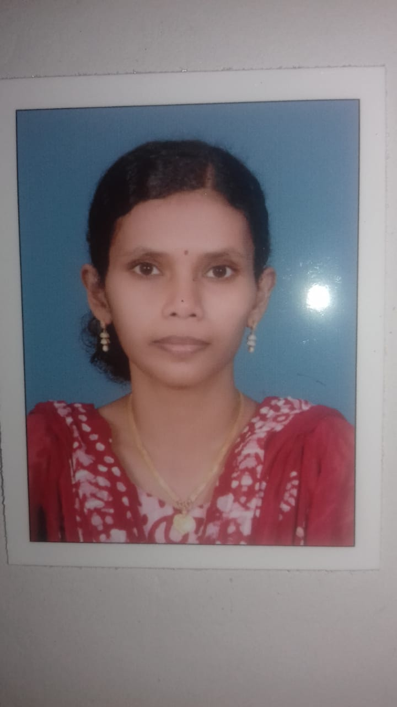

Photo
- Personal Details:

  - Name :Dr. SREEJA J .S

  - Designation :Assistant Professor

  - Date of joining :28/09/2010

  - Course taught :BA, MA

  - Area of specialization :Folklore

  - Address with Phone No. 9446222134
sreejajsl84@gmail.com

Permanent Address | Present Address
TC- 43/17 | TC- 43/17
Thottam | Thottam
Manacaud P.O | Manacaud P O
Thiruvananthapuram-695009 | Thiruvananthapuram-695009

- Academic Qualifications:

From P.G Level

Sl. No | Course | Institution | University | Year of  passing
1. | MA | University College | Kerala University | 2007
2 | NET |  | UGC | 2007
3 | Ph.D | N.S.S College, Nilamel | Kerala University | 2019
- Achievements and Awards:

No | Title of the award | Field | Sponsored by | International/  National/Regional | Year &  Month
1

- Research Projects: Nil

- Completed:

Sl.No. | Title of the Project | Duration | Consultancy/Funding Agency
 | -- | --- | ---
 | --- | --- | ---
- Ongoing:

Sl.No. | Title of the Project | Duration | Consultancy/Funding Agency
 | --- | --- | ---
 | --- | --- | ---

- List of publications in research journal and other magazines (last 5 years) in chronological order i.e from latest to the older:

Sl.No. | Title of the Publication | Name of Journal | ISSN/ISBN  No. | Year of Publishing
1. | Pulayapattu oru prathivayana | Vinjanakairali | Vol.52 | 2020
2 | Sen Soundarya Sasthravum Puthu malayalakavithayum | Malayalasahithi (Sahithya gaveshana Samahitham) |  | 2019

- Details of presentations in academic seminar & workshops ( last five years):

Sl.No | Title of the Paper presented | Theme of the conference/Seminar | Organized By | Whether  Int.Ntnl/Ntnl/state/ Colleges/University | Date/ Duration
1.

- No. of Ph.D Produced: Nil

Sl. No | Name of the Research Scholar | Title | Year | Specify in SSUS/Other  University

- No. of M.Phil/Ph.D Students at present:4

Sl. No | Name of the Research Scholar | Title | Year of Admission | Specify M.Phil/Ph.D | Specify in SSUS/Other  University
1. | Nila Vijayan | Dalith Vainjanikatha Pradeepan pampirikunninte Rachanakalil | 2021 | Ph.D | Kerala University
2 | Sreedevi B.S | Bhavukathwa Parinnamavum Sahithya Charithra Rachanayum | 2021 | Ph.D | Kerala University
3 | Shyja J | Akhyanathinte Rashtreeyavym Malayala Kavithayum | 2021 | Ph.D | Kerala University
4 | Amrith Lekshmi MT | Aadhunikananthara Malayalakavitha nirupannam | 2021 | Ph.D | Kerala University

Other information (Membership in academic bodies/professional bodies in Colleges, Universities, Other Govt. Institutions):

Sl.No. | Board | Name of the Authority | Period
1 | Syndicate
2 | Senate
3 | Academic Council
4 | Faculty
5 | Board of Studies
6 | Research/Doctoral Committee
7 | NSS/NCC
8 | Others (Specify)

- Any other relevant details (specify):
Books Published

NB: Enclose the proof of item I c and II - IX

