SCHOLAR SUPPORT PROGRAMME 2017-2018
THE REPORT
Scholar Support Programme is a New Initiative in Higher education by Directorate of Collegiate education has been successfully functioning in Government College Nedumangad since 2012-13.The programme aims imparting additional support to educationally backward students through additional lectures ,tutorials ,soft skill development etc through internal and external mentoring.
The details of SSP during the academic Year 2017 -18
The S.S.P was effectively implemented during this academic year (2017-18).The students of BA, BSc and Bcom with lowest percentage of marks were selected and they were provided with Five hours of External mentoring and Ten hours of internal mentoring in each semester
Allocation of Fund
The Collegiate Education Department has sanctioned a sum of Rupees 2,25,500 for running the Programmein the Academic Year 2017-18
As the instruction to conduct SSP classes were received much later during this Academic Year, that is ,by February 2018,Third and Fifth semester classes could not be provided to students. So for second and Third Year students only forth and sixth semester classes were provided . So the college Utilised only Rs 1,58000 . Out of this Rs 1,00000 was utilised for giving remuneration to teachers , 30,000 for study materials;6,000 for giving stationery kit for Students;Rs.7500 external mentoring ;and Rs.4,500 for office expense and Rs 12500 as remuneration to the Coordinator.
The Fund allotted to Third and Fifth semester for conducting Classes and purchasing study materials were refunded. Remuneration to Coordinator was claimed in accordance with the classes actually conducted . An Amount of Rs 67500 were refunded.
Subjects Allocation
During the current academic year five subjects were identified each for the first,second and third year degree students. For the First year Degree students 20 sessions (10 for the First and 10 for the second semesters) were arranged.As the Classes were already over by the time of receiving instruction to conduct Scholar Support Programme,Third and Fifth semester classes could not be provided to students. So for second and Third Year students only fourth and sixth semester classes were provided .
Remuneration to Resource Persons
Rs 1,00,000 was utilised for giving remuneration to teachers for engaging Classes under SSP .Classes were arranged before and after the regular class time and also in Saturdays
Teachers Diary and forms were distributed to resource persons and and they were collected back at the end of classes of each semester and properly recorded .
Study Material
An amount of Rs 30,000 has been spent for purchasing text books, and photocopy of study materials for SSPstudents of various Departments. The purchase were made by resource persons individually based on the content of paper selected for SSP and their receipts were obtained .
Stationery Kit
Stationery Kit (one pen&note Book) worth Rs.6000 were given to150 students of SSP .
Office expenses
Office expenses worth Rs 4500 were utilised for meeting the expense of Photo Copies ofTeachers Diary& Forms for Odd and Even Semesters ,refreshment expenditure of external mentoring,Purchase of stationery ,Photography Charges and Clerical charges .
External Mentoring.
An amount of Rs 7500 has been spent for External Mentoring. Two external mentoring Sessions were arranged for students .First sessions on ‘Confidence building’ with Three hour duration was handled by Mr Dilshad Bin Ashraf ,Assistant Professor of Psychology,Mannaniya College on 17/03/18 . Second Session on ‘ Easy English ’ with Two hour duration was conducted on 24/03/2018by Career Consultant Mr B Chakrapani (Rtd Superintendent NSSO Govt. Of India).Both sessions were highly beneficial to students for confidence building and improve their learning ability .
Feed back of external mentoring Classes were obtained from the participants and properly recorded.
The amount ear-marked for the Scheme has been fully utilised. The details regarding the expenditure, student’s attendance, list of books purchased, list of subjects and faculty members are attached . The report is submitted to the Principal for approval.

Details of subjects selected for internal mentoring
Subjects Selected and Sessions Engaged
First year Degree
Sl.No | Subjects selected | No of Students | No of sessions
1 | English | 10 | 20
2 | History | 10 | 20
3 | Malayalam | 10 | 20
4 | Maths | 10 | 20
5 | PCA | 10 | 20
Total 50 100
Second year Degree (4th Semester)
Sl.No | Subjects selected | No of Students | No of sessions
1 | Commerce | 10 | 10
2 | English | 10 | 10
3 | Economics | 10 | 10
4 | Maths | 10 | 10
5 | Physics with Computer Applications | 10 | 10

Third year Degree(6th Semester)
Sl.No | Subjects selected | No of Students | No of sessions
1 | Commerce | 10 | 10
2 | Economics | 10 | 10
3 | History | 10 | 10
4 | Malayalam | 10 | 10
5 | Maths | 10 | 10

Total Number of Students: 150
Total Number of Classes: 200

SCHOLAR SUPPORTPROGRAMME 2017-18
Details of Subject Taken
Sl No | Name OfTeacher | Semester | Deartment | Paper
1 | Reenakumari D | 4 | Commerce | Corporate Accounting
2 | Sujakumar K S | 6 | Commerce | Income Tax Law and Practice
3 | Nandu C J | 4 | Economics | Basic Tool for Economics
4 | Gopika G G | 6 | Economics | International Economics
5 | Rajesh Kumar C R | 1 | English | Listening Speaking and Reading
6 | Vinurajesh | 2 | English | Modern English Grammar and usage
7 | Dr Manju R | 4 | English | Readings in literature
8 | Beena K | 1&2 | Malayalam | Novel Charithravum Padavum(S1) Nadakam: Charithrm Padam Prayogam(S2)
9 | Dr L Alex | 6 | Malayalam | Malayalam Grammar
10 | Shyma Jacob | 1 | History | Methodology & perspectives of Social Science
11 | Thushad T | 2 | History | Cultural Formation of premodern World
12 | Dr Subhash S | 6 | History | Twentieth Centure Revolutions
13 | R Suresh | 1 & 2 | Maths | Methods of Mathematics(S1) Foundations of Mathematics(S2)
14 | Syamlal s | 4 | Maths | Algebra and CalculusII
15 | Sonu UK | 6 | Maths | Complex Analysis II
16 | Reshmy V K | 1 | PCA | Machanics ,Thermodynamics and properties of Matter
17 | Dr Gladston | 2 | PCA | Computer Programming in C
18 | Gopika M S | 4 | PCA | Classsical mechanics and theory of Relativity
EXTERNAL MENTORS
Sl N0 | Name | Designation
1 | Dilshad Bin Ashrah | Assistant Professor of Psychology Mannaniya College Palode |  | Confidence Building:"We are born to Burn"
2 | B Chakrapani | Career Consultant Nedumangad (Rtd Superintendent NSSO Govt. of India) |  | English for Competitive Exams

Sibi Natuvilakkandy,
Coordinator , Scholar Support Programme, Govt.College Nedumangad.
SSP 2017-18
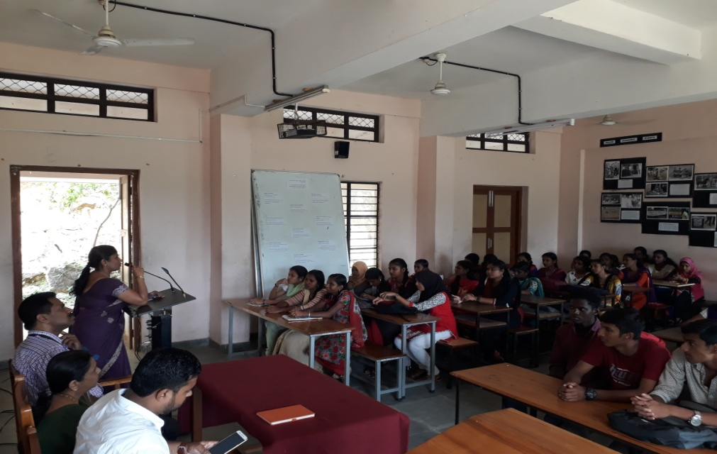
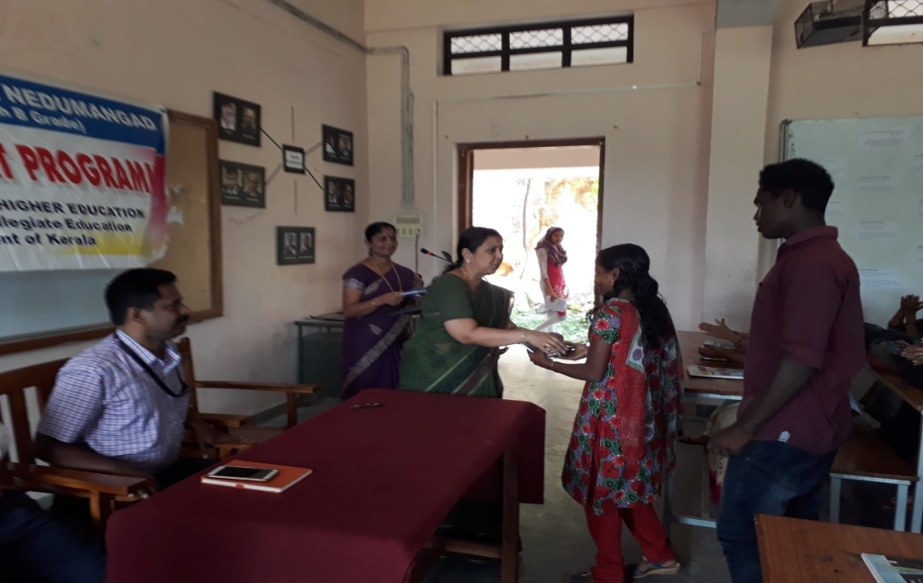
Inauguration and Distribution of Study Materials By Principal Dr Mini I
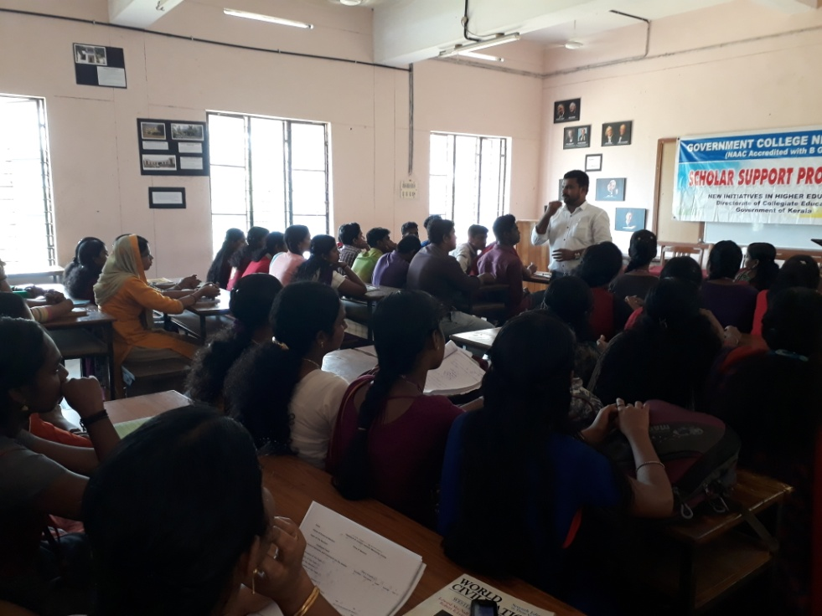
External Mentoring by Dilshad Bin Ashrah ,Assistant Professor of Psychology Mannaniya College Palode

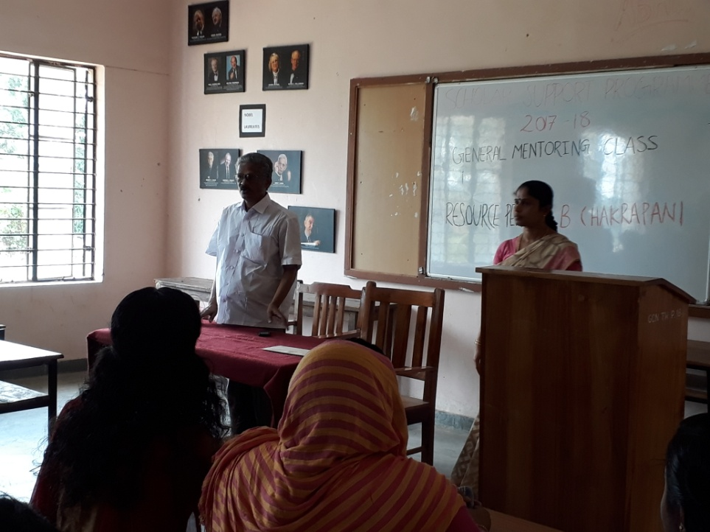
External Mentoring by B Chakrapani, Career Consultant Nedumangad (Rtd Superintendent NSSO Govt. of India)

