SCHOLAR SUPPORT PROGRAMME 2016-2017
THE REPORT
Scholar Support Programme (S.S.P), part of the New Initiatives in Higher Education, initiated by the department of Higher education, Govt. of Kerala, aims at imparting additional support to students in curricular areas of weakness.
The pilot phase of the Programme was started in the academic year 2012-2013.Initially S.S.P imparted curricular support to the First Year Degree students .It was extended to the Second Year Degree students during 2013-14 and to the Third Year students during 2014-15.
Scholar Support Programme (S.S.P) has been functioning in the Government college since 2012-13 Academic year onwards The students with lowest percentage of marks in the qualifying exam are to be included under the programme. They may be given additional curricular support through Teachers handling subjects in the college.
During the current academic year2016-17 five subjects were identified each for the first,second and third year degree students. For the First year Degree students 16 sessions (8 for the First and 8 for the second semesters) were engaged. The same number of Sessions were engaged for the Second Year Degree Programme. For the Third year students 20 sessions, 10 for the 5th semester and 10 for the 6th semester were engaged.
The S.S.P was effectively implemented during this academic year (2016-17).The students of BA, BSc and B com with lowest percentage of marks were selected. English ,Computer science ,History, Maths, and Commerce for the First Year ; Physics, Economics, Commerce &Computer Science besides English for the Second Year; Physics, Economics, Commerce ,History, and Maths for the Third year were identified for giving scholar support
Subjects Selected and Sessions Engaged
First year Degree
Sl.No | Subjects selected | No of Students | No of sessions
1 | English | 10 | 20
2 | History | 10 | 20
3 | Commerce | 10 | 20
4 | Maths | 10 | 20
5 | Computer Sience | 10 | 20
Total 50 100
Second year Degree
Sl.No | Subjects selected | No of Students | No of sessions
1 | English | 10 | 20
2 | Malayalam | 10 | 20
3 | Economics | 10 | 20
4 | Maths | 10 | 20
5 | Physics with Computer Applications | 10 | 20
Total: 50 100
Third year Degree
Sl.No | Subjects selected | No of Students | No of sessions
1 | Phyics With Computer Applications | 10 | 20
2 | Malayalam | 10 | 20
3 | Commerce | 10 | 20
4 | Economics | 10 | 20
5 | History | 10 | 20
Total: 50 100
Total Number of Students: 150
Total Number of Classes: 300
The Collegiate Education Department has sanctioned a sum of Rupees 2,25,500 for running the Programmein the Academic Year 2016-17. Out of this Rupees 1,50,000 was spent for giving remuneration to teachers , 12500 Rupees as remuneration to the coordinator; 45,000 for study materials;6,000 for giving stationery kit for Students;Rs.7500 external mentoring ;and Rs.4,500 for office expense.
Classes were engaged between 9 and 10 in the morning and between 3.30 and 4.30 in the evening. Classes were also arranged on Saturdays and Sundays .Rupees 1,50,000 have been disbursed to teachers as remuneration for conducting 300 classes. Rupees 12500 have been received as remuneration to the Coordinator. The amount of Rs 45,000 has been spent for purchasing text books, printouts and photocopy of study materials for SSPstudents various Departments .Some textbooks were given as study materials and their receipts were obtained .Some textbooks that are lend to the students were collected back and kept in SSP Book register . Stationery Kit (one pen&note Book) worth Rs.6000 were given to150 students of SSP.
Office expenses worth Rs 4500 were utilised for meeting the expense of Photo Copies of Teachers Diary& Forms of Odd and Even Semesters ,refreshment expenditure of external mentoring,Flex, Photography Charges and Clerical charges .
An amount of Rs 7500 has been spent for External Mentoring. Two external mentoring Sessions were arranged for students .First sessions on Carrer Guidance with Two hour duration was handled by Career Consultant Mr Chakrapani on 11/09/16 . Second Session with Three hour duration on How to become a successful leader was conducted on18/2/17 by Dr Kartha
An Amount of Rs 90,000 sanctioned for motivational visit has been fully utilised.
The amount ear-marked for the Scheme has been fully utilised. The details regarding the expenditure, student’s attendance, list of books purchased, list of subjects and faculty members and Programme time- table are attached. The report is submitted to the Principal for approval.
Sl No | Name of faculty | Semester | Subject
1 | Sujakumar KG | 1 &2 | Commerce
3 | Vinu Rajesh | 1 &2 | English
5 | Swapnakumar K | 1 &2 | History
7 | Anju Narayanan | 1 &2 | Maths
9 | Primsa I P | 1 | PCA
10 | Dr Gladston Raj S | 2 | PCA
11 | Dr Jayasankar | 3 | Economics
12 | Reena J | 3&4 | Economics
14 | Dr Manju R | 3&4 | English
16 | Pavithra Vijayan | 3&4 | Malayalm
18 | Anuja M V | 3&4 | Maths
20 | Shyja Rafeek | 3 | PCA
21 | Neethu R | 4 | PCA
22 | Reenakumari D | 5&6 | Commerce
24 | Dr Jayasankar | 5 | Economics
25 | Reena J | 6 | Economics
26 | Bijikumary P | 5 | History
27 | Dr R Sunilkumar | 6 | History
28 | Dr L Alex | 5&6 | Malayalm
30 | Gopika M S | 5 | PCA
31 | Dr Reshmy V K | 6 | PCA
External menotring
 | Name of Resource Person | Topic | Date & Time
 | B CHAKRAPANI  Rtd Supdt NSSO Govt of India | Career  Guidance | 18/11/2016  10 am to 12 pm
 | Dr N R U K Kartha  Former GM VSSC ISRO | How to become  successful leader | 18/02/2017  10 am to 1 pm

Sibi Natuvilakkandy,
Coordinator , Scholar Support Programme, Govt.College Nedumangad.

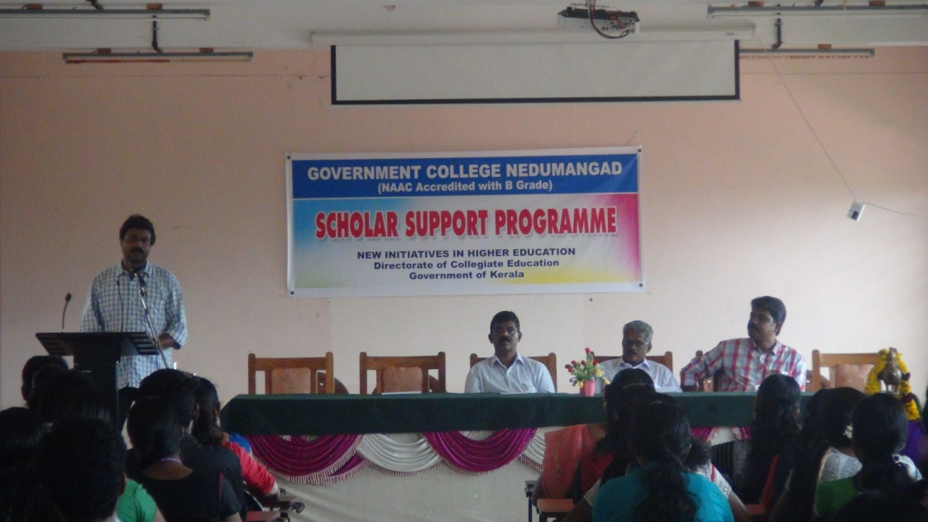
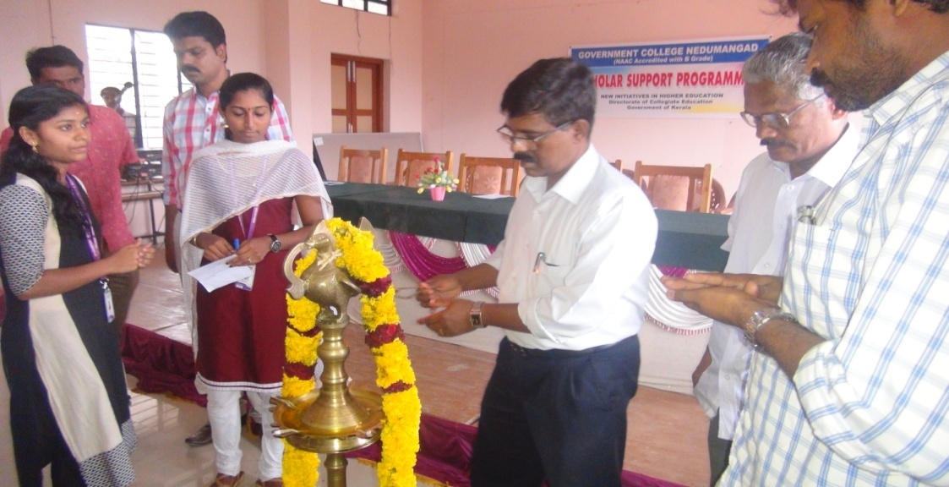
Inauguration of SSP 2016-17 by College principal Dr D K Sathish
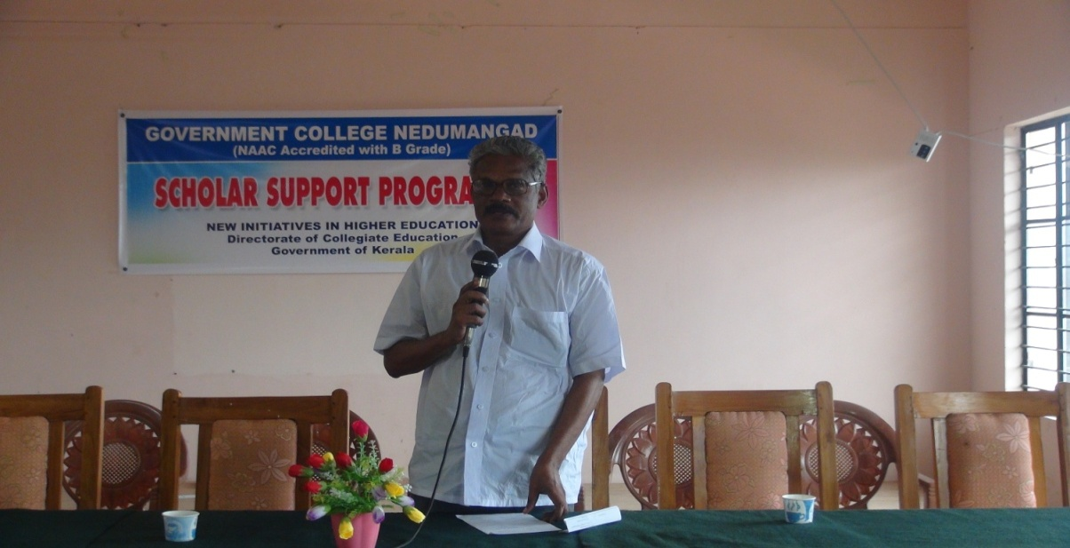
First External Mentoring Class by Sri B Chakrapani (Rtd Superintendent NSSO Govt of India
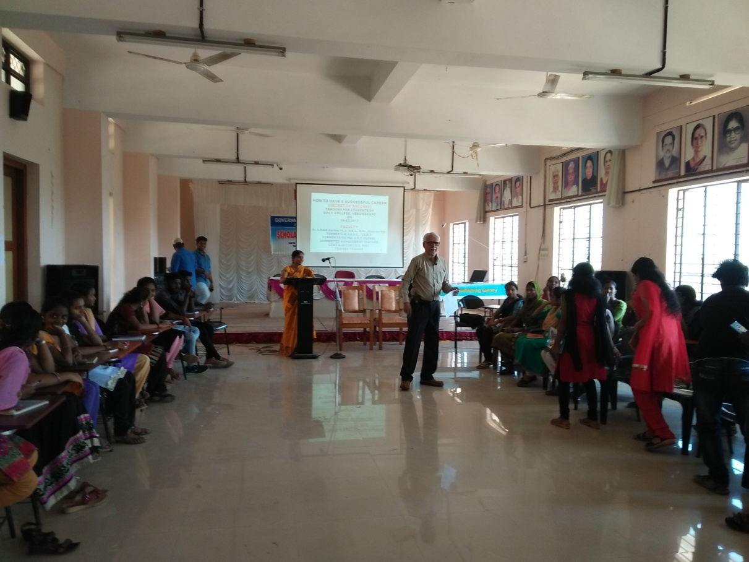
Second External Mentoring Class by Dr N R U K Kartha Former GM VSSC ISRO

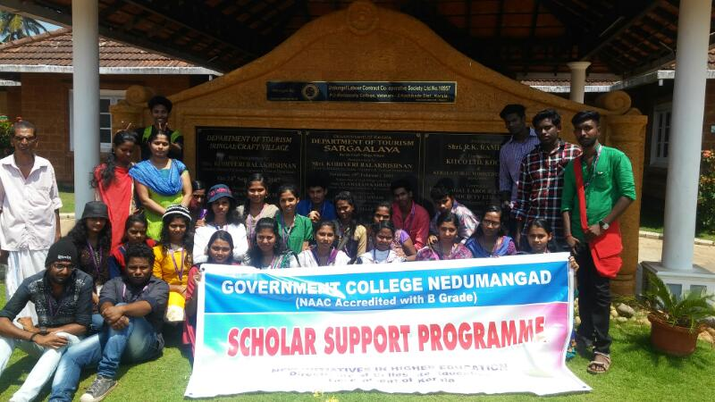
Motivational Visit ....At Sargalaya Craft Village Vatakara

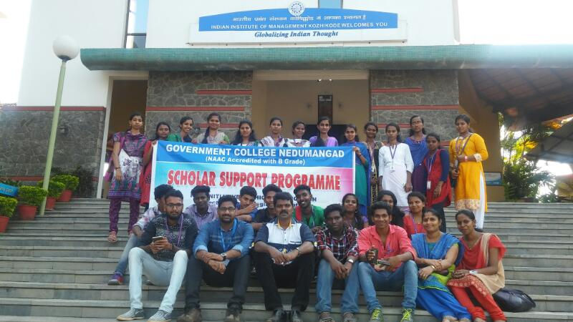
Figure 5: At Indian Institute of Management Calicut

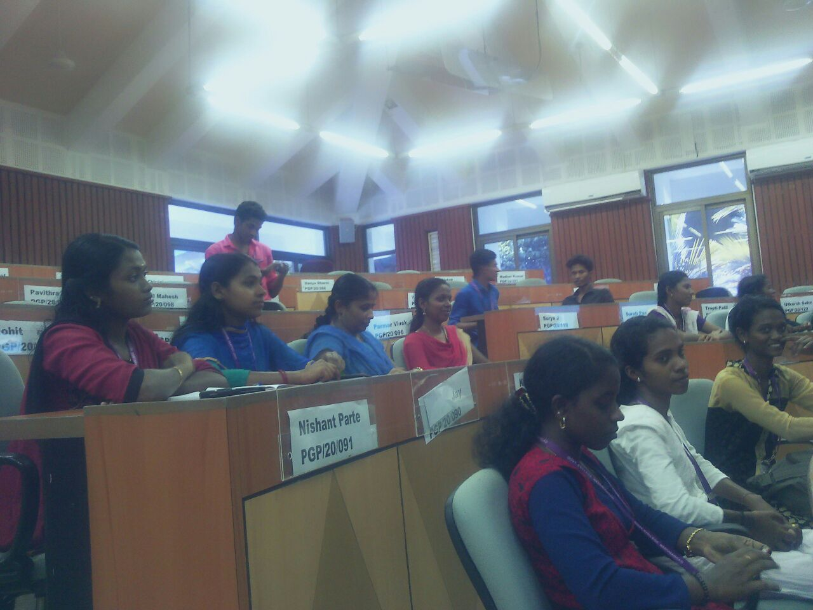
Figure 6 : At IIM Class Room

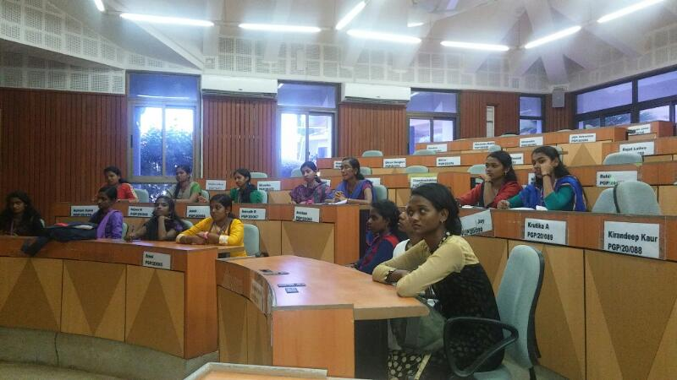
At IIM Class Room
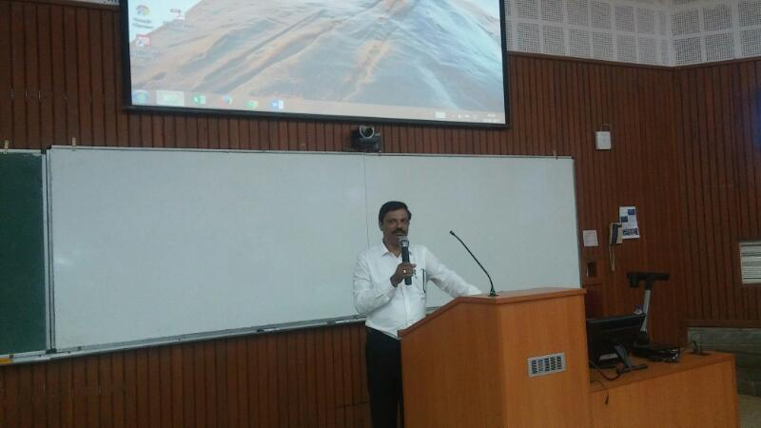
Figure 8: Interraction with IIM Faculty
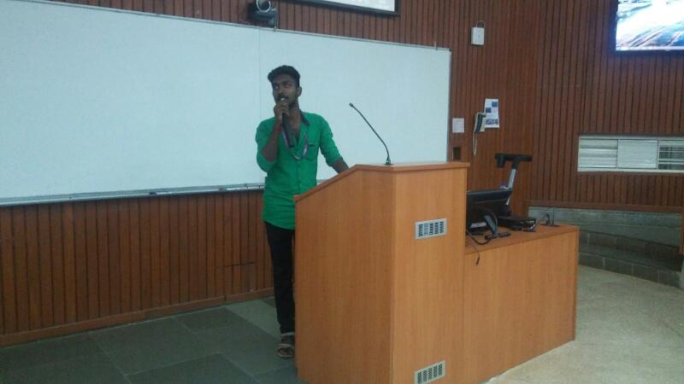

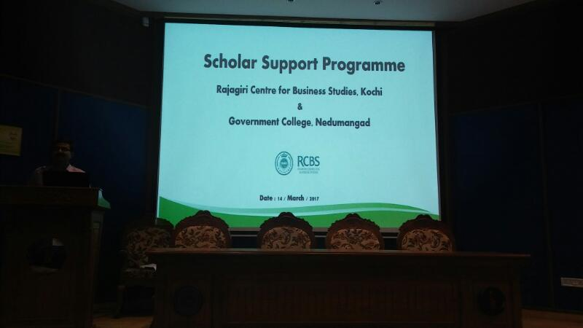
At Rajagiri Centre for Business Studies,Kochi

