GOVERNMENT COLLEGE NEDUMANGAD
HUMAN RIGHTS FORUM ACTIVITIES REPORT 2022-23

Human Rights Forum is intended to create awareness on human rights among students and educate them on the importance of respecting the rights of others. It is a student oriented community for promoting and spreading awareness on human rights and fundamental freedoms. It enabled them to build a culture among students that respects human rights and to understand the responsibilities that go along with rights.

WORLD ELDER ABUSE AWARENESS DAY (WEAAD) 2022
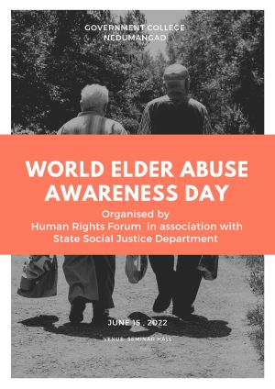
WEAAD is observed on June 15 every year, which provides an opportunity to the world to promote a better understanding of abuse and neglect of older persons. Human rights forum of our college, in association with State Social Justice dept organized the awareness programme, to promote dignity and respect of older adults. Dr Alex L, Vice Principal, along with students and teachers have taken the pledge encouraging all to stand up for the rights of the older people.
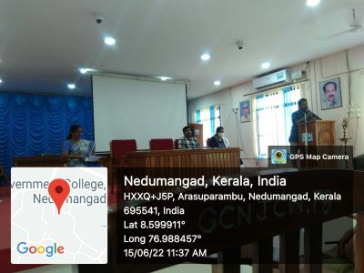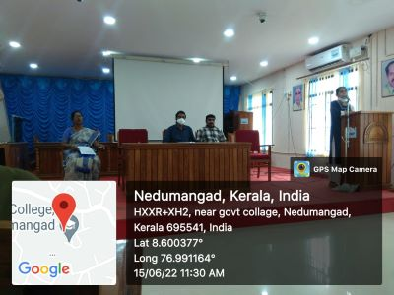

VIGILANCE AWARENESS WEEK 2022
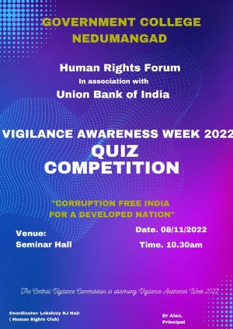
Human rights Forum in association with Union Bank conducted a Quiz Competition on “ Corruption Free India for a Developed Nation” on 8/11/2022 on the eve of Vigilance Awareness Week 2022. Jerin M Paul, Chief Manger Union Bank of India, Regional office addressed to students about the perils of corruption and create awareness to combat corruption and generate community responsibilities. He distributed prizes to the winners and also planted a tree sapling at the college premise.
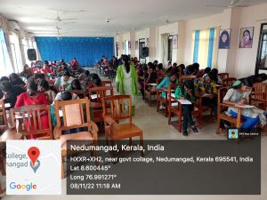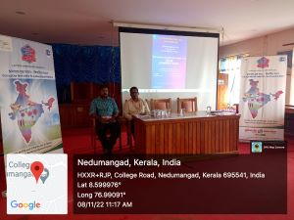
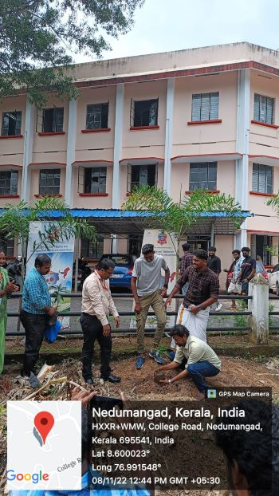
HUMAN RIGHTS DAY CELEBRATIONS 2022
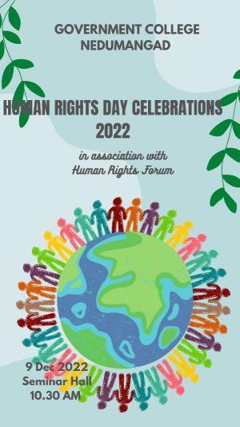
Human Rights day is celebrated every 10 December to create awareness and mobilize political will to promote respect for the rights and freedoms enshrined in the Universal Declaration of Human Rights adopted by the United Nations General Assembly in 1948. On 09/12/2022, Human Rights Forum organised the campaign to promote and recognise the 75TH anniversary of Universal Declaration of Human Rights. The theme of 2022 Human Rights Day is “Dignity, Freedom and Justice for all.” All faculties and students pledge to uphold the values of human rights and responsibilities.

